Explore the Coast

Grants

ANNOUNCEMENT & APPLICATION
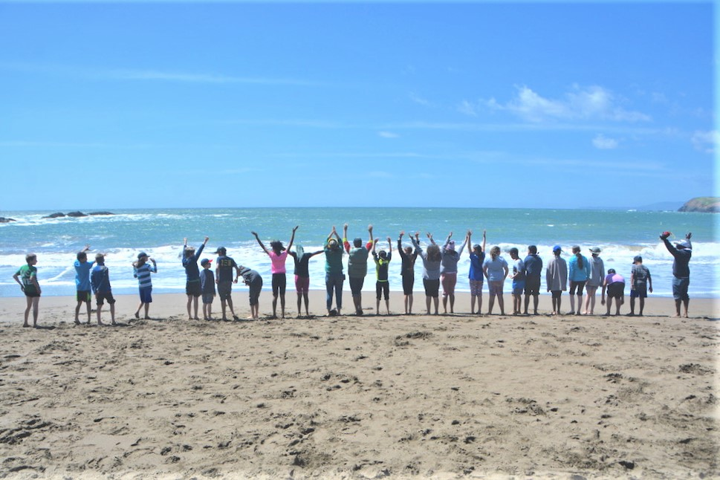

Coastal Conservancy Explore the Coast Grants

The California State Coastal Conservancy (Conservancy) announces the availability of grants to public agencies, tribes and nonprofit organizations for programs that facilitate and enhance the public’s opportunities to explore California’s spectacular coast. The ocean, coast, and beaches have long been recognized and used as spaces of joy, relaxation, and healing. The Explore the Coast grant program seeks to provide coastal experiences for people and communities who face challenges or barriers to accessing or enjoying the coast (“ETC Priority Communities”).

ETC Priority Communities may include but are not limited to lower-income individuals and households, people with disabilities, people of color, immigrant communities, foster youth, and others.

Projects should also meet one or more of the following priorities:
- Provides an enjoyable experience at the coast.
- Reduces economic, physical, operational, or societal barriers to accessing or enjoying the coast.
- Inspires ongoing coastal resource stewardship ethic through active learning and interactive activities.

Approximately $1.4 million will be awarded in this grant round. There is no minimum grant amount, and the anticipated maximum grant amount is $50,000. Applicants should apply for projects that could start in late 2020 or early 2021 and will be completed by February 2023. The Conservancy will base the size of the award on each project’s needs, its overall benefits, and on the extent of competing demands for funds.

The Conservancy will hold a webinar on Wednesday, February 19, 2020, 11 am – 12 pm to walk through the Explore the Coast Grant Program and address common questions regarding the application. Potential project applicants are encouraged to attend. If you want to attend the informational webinar, please register at this link.

Applications must be submitted via email to grants@scc.ca.gov by Monday, March 30, 2020 (further details below).

Background

The Coastal Conservancy is a non-regulatory state agency that works to preserve, improve, and restore public access, natural resources, and agricultural lands along the Pacific coast and the San Francisco Bay shoreline and its adjacent counties. The Conservancy undertakes projects and works with public agencies and non-governmental organizations to accomplish these goals.

Increasing public access to California’s coast is a core component of the Conservancy’s work. With the Explore the Coast Program, the Conservancy seeks to support programs and organizations that work with people and communities who face challenges accessing the coast and/or enjoying the coast. The Explore the Coast grants will not fund construction of new facilities. However, through other grant programs, the Conservancy has funded the construction of hundreds of projects to build new trails, trailheads and other amenities (beach stairways, bathrooms, overlooks, etc.).

Funding for Explore the Coast grants is expected to come from the Coastal Access Account, which comes from fees for permits issued by the California Coastal Commission, and the California Environmental License Plate Fund.

Eligible Applicants: Public agencies, tribes, and nonprofit organizations are eligible for funding. To be eligible, a nonprofit organization must qualify under the provisions of Section 501(c)(3) of the Internal Revenue Code.

Eligible Project Locations: Projects must involve visiting the coast of California or the shore of San Francisco Bay. The Conservancy is very interested in supporting programs that bring participants to the coast from throughout the state.

Eligible Projects: Eligible projects include a wide range of programs and activities that will help to bring more people to the coast and/or enhance their experience at the coast. At least 50% of participants served by the grant must be from communities who face barriers accessing the coast. Below are some examples of projects that are eligible and ineligible for funding. This is not an exhaustive list:
- Providing transportation for people from communities who have faced barriers accessing or enjoying the coast to take part in recreational, educational, or stewardship programs.
- Projects that reduce economic, physical, or societal barriers to accessing or enjoying the coast.
- Projects that maximize barrier-free access to the coast for persons with disabilities.

- Festivals, docent programs, or other outreach events to raise public awareness of access opportunities and/or promote recreational uses of the coast.
- Projects that provide overnight coastal experiences for participants.
- Projects that support volunteer stewardship of Coastal Trail segments or other coastal access points and habitats.
- Projects that promote the use of public transit to access the coast.
Ineligible Projects:
- Projects that only include classroom-based programs and/or curriculum.
- Construction of facilities.
- Projects that are solely beach clean-ups.

Questions: Prospective applicants are encouraged to discuss their projects with Conservancy managers prior to submitting their applications. Note: Regional contacts are based on regions participants come from to join the program, not on the location of the program itself.

Questions about the application process and potential projects may be directed to:

- Karyn Gear, North Coast Program Manager, 510-286-4171, karyn.gear@scc.ca.gov
  - Region 1, North Coast (Del Norte, Humboldt, Lake, Mendocino, and Sonoma)
  - Region 2, Far North (Butte, Glenn, Lassen, Modoc, Nevada, Plumas, Shasta, Siskiyou, Tehama, Trinity)
- Moira McEnespy, San Francisco Bay Area Program Manager, 510-286-0317, moira.mcenespy@scc.ca.gov
  - Region 3, Bay Area (Alameda, Contra Costa, Marin, Napa, San Francisco, San Mateo, Santa Clara, Solano)
  - Region 4, Sacramento & Sierras (Alpine, Amador, Calaveras, Colusa, El Dorado, Mono, Nevada, Placer, Sacramento, Sierra, Sutter, Stanislaus, Tuolumne, Yolo, Yuba)
- Trish Chapman, Central Coast Program Manager, 510-286-0749, trish.chapman@scc.ca.gov
  - Region 5, Central Coast (Monterey, San Benito, Santa Cruz, San Luis Obispo, Santa Barbara)
  - Region 6, San Joaquin Valley (Fresno, Kern, Kings, Madera, Mariposa, Merced, San Joaquin, Stanislaus, Tulare)
- Megan Cooper, South Coast Program Manager, 510- 286-4172, megan.cooper@scc.ca.gov
  - Region 7, South Coast (Los Angeles, Orange, Ventura, San Diego)
  - Region 8, Inland Southern California and Deserts (Imperial, Inyo, Riverside, San Bernardino)

Helpful Resources: The following resources may be helpful for the preparation of your grant application.
- Sample Grant Terms – Please review the sample grant terms before completing your application. Please note, in particular, the insurance requirements for ETC grants. If the requirements will result in higher insurance premiums for the applicant, this cost can be included in the grant budget.
- Sample Budget and Budget Narrative

Application Submittal: The Explore the Coast grant application is attached. Completed applications should be submitted via email to grants@scc.ca.gov. The application should be emailed as a word document. Applicants are welcome, but not required, to attach a small number of relevant photos (preferably as jpgs) and maps (as jpgs or pdfs); these attachments should not exceed 10MB total. Relevant photos and maps should demonstrate the location, context, and proposed outcomes of the project.

Please be aware that all documents submitted to the Conservancy become public documents. The Conservancy will assume that submitted photos are permissible for use by the Conservancy unless the applicant clarifies otherwise.

Submission Dates: Applications must be submitted to grants@scc.ca.gov by Monday, March 30, 2020.

Application Review and Grant Award Process

Project Review: Conservancy staff will evaluate each application based on how well it meets the Selection Criteria stated below. Applicants may be contacted to provide additional information during the review process. Conservancy staff may seek assistance in evaluating the proposals from individuals and/or technical experts with pertinent expertise from other governmental agencies, non-profit organizations, and other entities. Applications will also be reviewed by the Explore the Coast Advisory Board. Applicants can anticipate being notified as to whether their project will be recommended for funding by mid-summer 2020.

Selection Criteria: Projects will be evaluated against the following criteria:
- The percentage of participants served who face challenges accessing or enjoying the coast (at least 50% of participants served by the grant must be from communities that face barriers accessing the coast).
- The extent to which the project provides enjoyable experiences at the coast.
- The extent to which the project reduces economic, physical, or societal barriers to accessing or enjoying the coast.
- The extent to which the project inspires an ongoing coastal resource stewardship ethic through active learning, interactive exploration, and providing an engaged and authentic coastal experience.
- The extent to which the project is inclusive of all participants by considering differences in cultural and social backgrounds, past experiences, physical capabilities, knowledge, comfort levels, etc.
- The extent to which the project provides overall long-term positive impacts on participants (including leadership development opportunities, multi-year or extended touch programs, family or support system involvement, peer-to-peer mentorship, or solutions to overcome ongoing barriers).
- Methodology for evaluating program effectiveness.
- Project description is clear, and budget is reasonable.
- Project is ready to proceed in a timely manner.
- The applicant’s overall ability to carry out the proposed project.

Conservancy Board Approval: Projects recommended by staff for funding are subject to approval by the Coastal Conservancy Board at a noticed public meeting. Conservancy staff will present the recommendations for Explore the Coast grants to the Conservancy Board in September 2020. Applicants are required to provide staff with all pertinent information in a timely manner to ensure Board consideration.

Project funding will not be available until a grant agreement between the Conservancy and the grantee has been executed which will generally take at least six weeks after Board approval (Fall 2020).

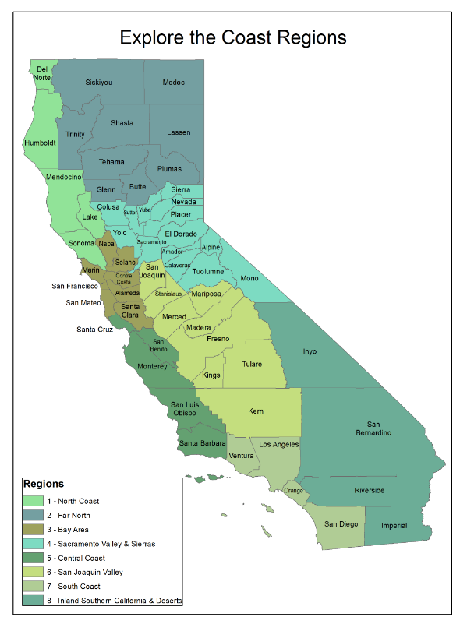
Map of Explore the Coast Project Regions

EXPLORE THE COAST GRANT APPLICATION
CONTACT INFO
Organization*
Contact Person |  | Email
Position/Title
Phone |  | Fax
Address
Federal Tax ID#
*If applicable, Include name of fiscal or project sponsor. – If applicant qualifies as a 501(c)(3) organization, provide your IRS 501(c)(3) letter and Articles of Incorporation. Note: Applicants who have submitted these documents in the past two years do not need to resubmit.

PROJECT INFO
Project Name
Amount Requested *round up to nearest hundred | $ | Total Project Cost | $
Start Date |  | End Date

LOCATION INFO
What specific facility(ies) will the project use/visit (e.g., Santa Monica Pier, Stinson Beach, Point Reyes National Seashore)?

Directions: Please limit your response to the following 13 questions to no more than nine pages. You may delete the instructions for each question if you need more space.

- Explore the Coast Program Priorities. Briefly describe your project and how it meets one or more of the Explore the Coast Program Priorities below:
- Provides an enjoyable experience at the coast.
- Reduces economic, physical, operational, or societal barriers to accessing or enjoying the coast.
- Inspires ongoing coastal resources stewardship ethic through active learning and interactive activities.

- ETC Priority Communities Served. The Explore the Coast grant program seeks to provide coastal experiences to people and communities who face challenges or barriers to accessing or enjoying the coast (“ETC Priority Communities”).

  - Provide a brief explanation of the community(ies) that will be served by the project. In your explanation, be as specific as possible about the demographics of the participants
served.
  - Where and how will you perform outreach to recruit participants (i.e. bilingual flyers, community workshops, working with Title 1 schools, etc.)?
  - Describe how your program is inclusive of all participants and takes into consideration differences in cultural and social backgrounds, past experiences, physical capabilities, knowledge, comfort levels, etc. when participating in program activities.
  - How will people with disabilities be served through your program? Provide details on how you will address inclusion and accommodation of such participants.

- Summary Tables. To the best of your abilities, please fill out the two tables below ONLY with the estimated numbers of participants you expect to serve should you receive Coastal Conservancy funding.

Participants served by Coastal Conservancy Grant in Budget Below | Estimate Number Served by Coastal Conservancy Grant
Total number of participants
Total number of participants from ETC Priority Communities (including: lower-income individuals and households, people with disabilities, people of color, English as a
Second Language (ESL) communities, immigrant communities, foster youth, and others.)

Regions of the State  (see map in attached announcement) | Estimated Number of Participants from Each Region Served by Grant
Region 1, North Coast
Region 2, Far North
Region 3, Bay Area
Region 4, Sacramento Valley & Sierras
Region 5, Central Coast
Region 6, San Joaquin Valley
Region 7, South Coast
Region 8, Inland Southern California and Deserts

- Participant Experience. What specifically will the participants do? Describe ways in which the program is designed to have long-term positive impacts on participants. This can include leadership development opportunities, multi-year or extended touch programs, family or support system involvement, peer-to-peer mentorship, or solutions to overcome ongoing barriers.

- Program Duration. Estimate duration of program (e.g. one day event, overnight, weeklong) and the number of hours each participant will spend in your program (e.g. 3-hour surfing lesson, 1.5 hours of classroom science activities, 2-hour sailing trip).

- Specific Tasks and Schedule. Identify the specific tasks that will be undertaken and the work that will be accomplished for each task. Please be specific about the actual work the grant would fund.

# | Task Name | Description | Completion Date
1
2
3
4
Add or delete rows as necessary.

- Project Evaluation. What are your organization’s metrics and methods for measuring the success of the project or program?

Does your program conduct pre and/or post surveys of participants? YES NO

- Applicant capacity. Briefly describe the organizational capacity of the applicant. When was your organization established? Will this grant fund an existing program or a new program? Describe how your staff and board reflects the community your project intends to serve through the grant.

If applicant is a nonprofit organization, has your organization submitted the Conservancy’s Nonprofit Pre-Award Questionnaire within the last two years? YES NO

If no, please complete this questionnaire, and submit with your application along with your organization’s IRS 501(c)(3) letter and Articles of Incorporation.

- Preliminary Budget. In the budget table below, relist the tasks identified in question #6 above, and provide the estimated cost (cash amounts) and the funding sources (applicant, Conservancy, and other) for each listed task. Round the cost for each task up to the nearest $100. The table will automatically sum the totals for each row and column. To do this, highlight the whole table and hit F9. See Sample budget and budget narrative.

Note: Describe any in-kind services or contributions in question #13. DO NOT include in-kind services or contributions in the table below.

Task Number | Task | Coastal Conservancy  Funds | Other Funds *Do not include In-Kind services in this table | Total Cost
1 |  |  |  | $ 0
2 |  |  |  | $ 0
3 |  |  |  | $ 0
4 |  |  |  | $ 0
 | Fiscal Sponsorship Fee  (if applicable) |  |  | $ 0
 | Indirect costs (if applicable)* |  |  | $ 0
TOTAL |  | $ 0 | $ 0 | $ 0
* Indirect costs can be up to 15% of total value of grant

- Budget Narrative. For each task, explain the basis of the estimated cost listed above. For example, explain what kind of costs the grant will pay for (e.g. participant or subcontractor fees, staff, food, project supplies/equipment, travel).

- Cost to Participants. Describe costs, if any, to participants in your program. Identify whether grant funding would enable the program to be free or subsidized.

- Other Funds. Provide information about the specific source of any “Other Funds”, and whether that funding has been secured or is dependent on a future award or authorization.

- In Kind Services. In-kind services or contributions include volunteer time and materials. Describe and estimate the value of expected in-kind services.

Additional Information (Optional).
Please help us to better understand who the ETC program is serving by filling out the table below to the extent that you are able. Numbers can be approximate.

ETC Priority Communities | Estimated number of participants
Low-income
People with Disabilities
English as Second Language Learners
Foster Youth
People of Color
Black
Asian / Pacific Islander
Latinx
Native American
Multi-Racial
Other ethnicity, please specify:
Other ethnicity, please specify:
Other ethnicity, please specify:
Other communities facing barriers accessing or enjoying the coast.
EG: People who were formerly incarcerated
EG: Veterans
Other, please specify
Other, please specify
Other, please specify

