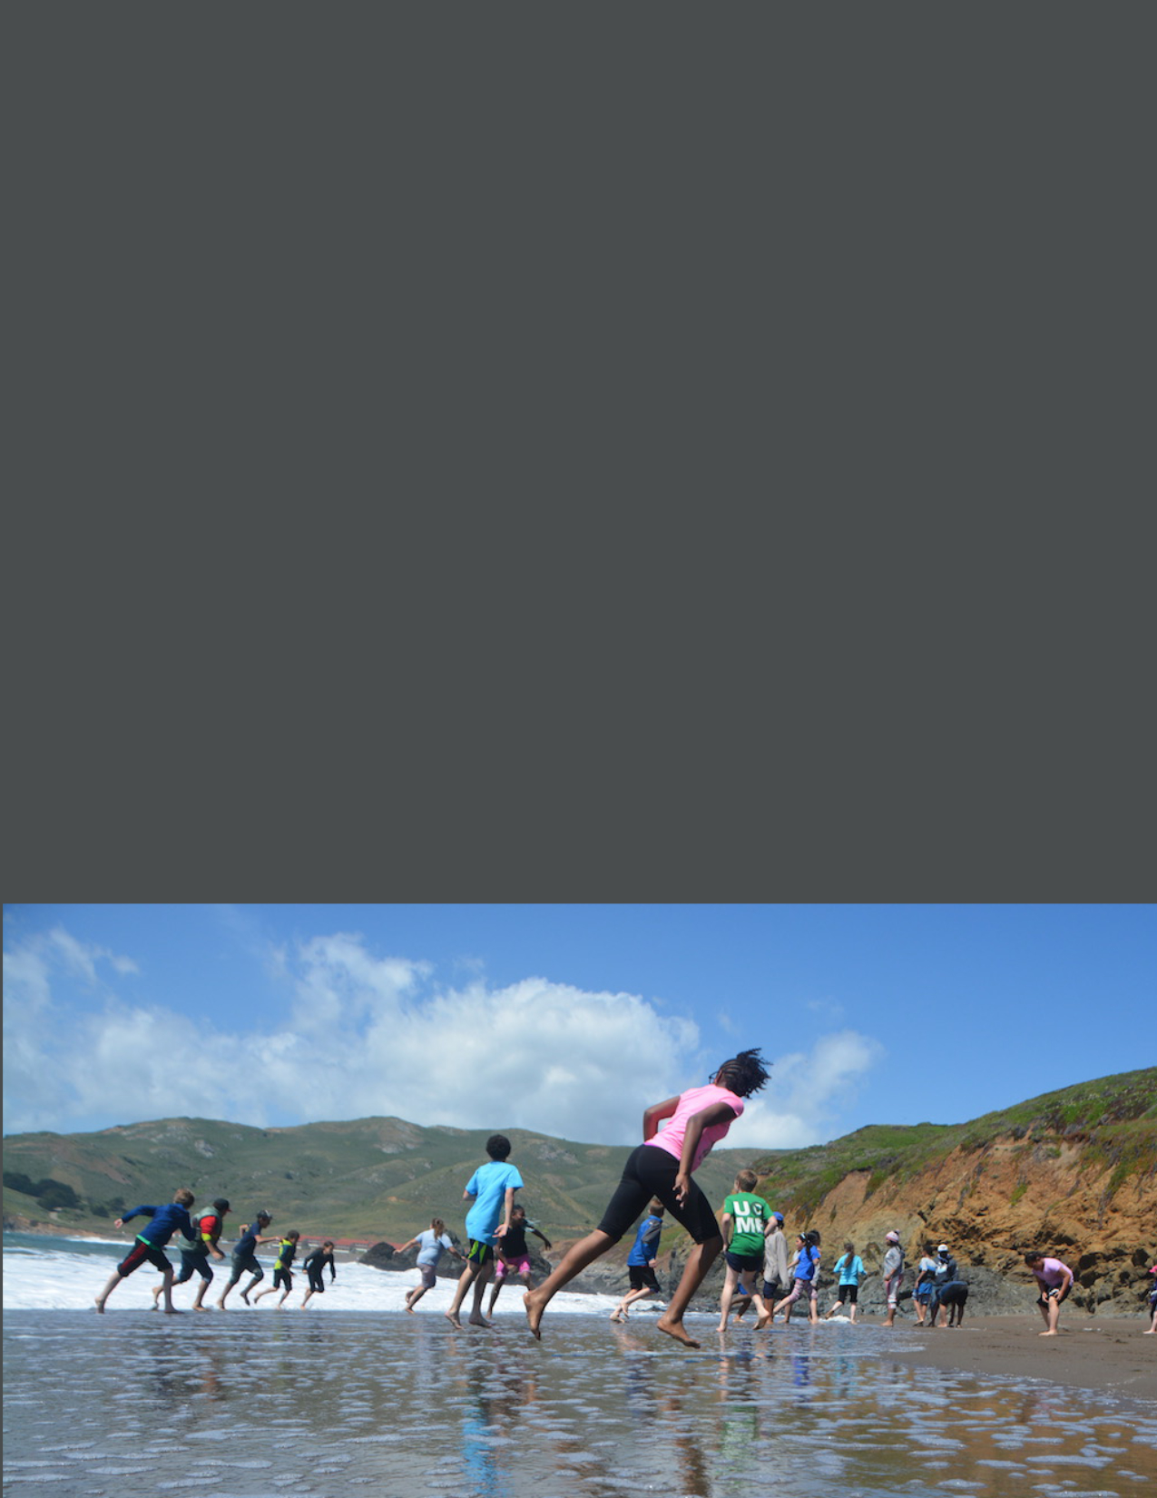
Explor
Explore the Coast Grants

2022 ANNOUNCEMENT & APPLICATION
Released January 6, 2022

Application is attached to this announcement
Submit Application via email to grants@scc.ca.gov
Application Due Friday, March 11, 2022.
For questions only, email explorethecoast@scc.ca.gov
Please read the request for proposal thoroughly

Explore the Coast Grants Request for Proposals
Background

The California State Coastal Conservancy (Conservancy) announces the availability of grants to public agencies, federally-recognized tribes and indigenous communities, and nonprofit organizations for programs that facilitate and enhance the public's opportunities to explore California's spectacular coast and San Francisco Bay shoreline. The ocean, coast, and beaches have long been recognized and used as spaces of joy, relaxation, and healing for many Californians. The ability to experience the coast without fear of physical barriers, feelings of not belonging, or financial challenge is crucial to how individuals cultivate their lifelong connections with the coast. The Explore the Coast grant program seeks to provide enjoyable coastal experiences for people and communities who face challenges or barriers to accessing or enjoying the coast ("ETC Priority Communities").

ETC Priority Communities may include but are not limited to lower-income individuals and households, people with disabilities, people of color, indigenous communities, immigrant communities, foster youth, and other historically excluded communities who face societal challenges or barriers to accessing or enjoying the coast.

Projects should also meet one or more of the following priorities:
- Provide an enjoyable experience at the coast.
- Reduce economic, physical, operational, or societal barriers to accessing or enjoying the coast.
- Inspires ongoing coastal resource stewardship ethic through active learning and interactive activities.

Approximately $9 million is available for this grant round. The Coastal Conservancy was awarded a one-time $14 million General Fund appropriation for the Explore the Coast Grant Program to spend over 4 years. This program will continue for subsequent grant cycles, but we cannot ensure these large appropriations in the future due to the unpredictable nature of the State fund appropriations.

Award Amount
Applicants may request a grant amount of up to $200,000 for a 2-year project or $100,000 for a 1-year project.

Project Start and End date
Applicants should apply for projects that could start in late 2022 or early 2023 and aim to be completed by February 2025. The Conservancy will base the size of the award on each project's needs, its overall benefits, and the extent of competing demands for funds.

Project Eligibility

The Coastal Conservancy is a non-regulatory state agency that works to preserve, improve, and restore public access, natural resources, and agricultural lands along the Pacific coast, San Francisco Bay shoreline, and adjacent counties. The Conservancy undertakes projects and works with public agencies, tribes, and nonprofit organizations to accomplish these goals.

Increasing public access to California's coast is a core component of the Conservancy's work. With the Explore the Coast Program, the Conservancy seeks to support programs and organizations that work with people and communities who face challenges accessing the coast and/or enjoying the coast.

Eligible Applicants
Public agencies, federally-recognized tribes and indigenous communities, and nonprofit organizations are eligible for funding. To be eligible, a nonprofit organization must qualify under the provisions of Section 501(c)(3) of the Internal Revenue Code. Other community-based organizations and tribes or indigenous communities that are not federally-recognized may apply with a 501(c)(3) fiscal sponsor.

Eligible Project Locations
Projects must involve visiting the coast of California or the shore of San Francisco Bay. The Conservancy is interested in supporting programs that bring participants to the coast from throughout the state, including inland areas.

Eligible Projects
Eligible projects include a wide range of programs and activities that help to bring people to the coast and/or enhance their experience at the coast. At least 50% of participants served by the grant must be from ETC Priority Communities. Competitive projects will provide participants with joyful and culturally relevant coastal experiences, with other benefits such as ecosystem stewardship and environmental education as secondary benefits.
Examples of eligible projects:
- Providing transportation for ETC Priority Community members to participate in recreational, educational, or stewardship programs.
- Projects provide coastal experiences for people that reduce economic, physical, or societal barriers to accessing or enjoying the coast.
- Projects provide coastal experiences for persons with disabilities that maximize barrier-free access to the coast.
- Project facilitates festivals, docent programs, or other outreach events to promote and increase coastal recreational opportunities for ETC priority community members. Applicants should have a clear plan for engaging ETC priority community members in large-scale festivals open to the public.
- Projects that provide overnight coastal experiences for participants.
- Projects that support the use and volunteer stewardship of Coastal Trail segments or other coastal access points and habitats.
- Projects that promote the use of public transit to access the coast.
Ineligible Projects
Examples of ineligible projects include:
- Projects that focus primarily on classroom-based programs and/or curriculum.
- Projects that solely involve beach clean-ups or volunteer ecosystem stewardship.
- Construction of new facilities. Please note, however, that the Conservancy has funded hundreds of projects to build new trails, trailheads, and other amenities (beach stairways, bathrooms, overlooks, etc.) through other funding programs. Please contact us directly if you are pursuing this type of project.
We encourage you to contact us if you have any questions regarding the eligibility of your project. Additional information on how to reach us is located below.

Application Submittal

The Explore the Coast grant application is attached and linked on our website.
Submit completed application as a word document to grants@scc.ca.gov by
Friday, March 11, 2022, by 5 pm.

Applicants are welcome to attach supplemental documents, including up to 3 relevant photos (preferably as jpg), programs, and schedules with their application submission; these attachments should not exceed 10MB total. Relevant documents, including photos, should provide examples of the participant activities of the proposed project.

Please be aware that all documents submitted to the Conservancy become public documents. The Conservancy will assume that submitted photos are permissible for use unless the applicant clarifies otherwise.

Contact Us for Technical Assistance

Prospective applicants are highly encouraged to discuss their projects with the Conservancy staff before submitting their applications. We can help you make your application as competitive as possible. You can request a consultation, join our webinar, and/or join the technical assistance meetings.

Contact Information
To request a project consultation call, please email explorethecoast@scc.ca.gov. Please provide a brief description of your project idea, the general area your participants will come from, and the name, phone number, and email of the person to be contacted. We will respond within 3 business days. Potential applicants can contact us any time before the application due date for technical assistance.

Webinar
The Conservancy will hold a webinar on January 21, 2022, 2 pm – 3 pm to walk through the Explore the Coast Grant Program and address questions regarding the application. Potential project applicants are encouraged to attend. The registration link for the webinar is here. The recorded webinar will be posted on scc.ca.gov afterward.
Technical Assistance- Office Hours
The Conservancy will offer two one-hour Technical Assistance “Office Hour” sessions where SCC staff will answer more specific grant questions and provide guidance with application preparation to potential applicants via zoom meeting. Break-out rooms will be an option for one-on-one assistance.
- February 3, 2022, 4 pm – 5 pm Technical Assistance registration link is here.
- February 24, 2022, 11 am – 12 pm Technical Assistance registration link is here.

Anticipated Grant Schedule

Grant Round 2022
January 6, 2022 | Release of Request for Proposal
January 21, 2022 | ETC Webinar
February 3, 2022 | Technical Assistance #1
February 24, 2022 | Technical Assistance #2
March 11, 2022 | Applications Due at 5 pm
March 11–July 1 | SCC Staff & ETC Advisory Board review of applications
Late July 2022 | Selection of projects to recommend for funding
September 22, 2022 | Conservancy Board meeting, for project funding recommendations
Aug–Dec 2022 | Complete grant pre-conditions and execute grant agreements
Late 2022 or Early 2023 | Grantees start work on their projects

Application Review and Grant Award Process

Project Review
Conservancy staff will evaluate each application for how well it meets the Selection Criteria stated below. Applicants may be contacted to provide additional information during the review process. Conservancy staff may seek assistance in evaluating the applications from individuals and technical experts with pertinent expertise from other governmental agencies, nonprofit organizations, and other entities. After an initial round of review, a subset of the applications will be reviewed by the Explore the Coast Advisory Board.

Applicants will be notified in late July 2022 if their project has been selected to bring to the Conservancy's Board for final approval. Applicants will be notified of the final decision after the Conservancy's September 22, 2022 Board Meeting.

Selection Criteria
Projects will be evaluated against the following criteria:
- The percentage of participants served who face challenges accessing or enjoying the coast (at least 50% of participants served by the grant must be from ETC priority communities).
- The extent to which the project provides enjoyable experiences at the coast.
- The extent to which the project reduces economic, physical, or societal barriers to accessing or enjoying the coast.
- The extent to which the project inspires an ongoing coastal resource stewardship ethic through active learning, interactive exploration, and providing an engaged and authentic coastal experience.
- The extent to which the project includes all participants by considering differences in cultural and social backgrounds, past experiences, physical capabilities, knowledge, comfort levels, etc.
- The extent to which the project provides overall long-term positive impacts on participants (including leadership development opportunities, multi-year programs or programs that engage participants over multiple occasions, family or support system involvement, peer-to-peer mentorship, or solutions to overcome ongoing barriers).
- Methodology for evaluating program effectiveness.
- Project description is clear, and the budget is reasonable.
- Project is ready to proceed in a timely manner.
- The applicant's overall ability to carry out the proposed project (organizational capacity, experience working with the target community, cultural-humility and cultural-relevancy, experience running similar programs, etc.)

Conservancy Board Approval
Projects recommended by staff for funding are subject to approval by the Coastal Conservancy Board at a public meeting. Conservancy staff will present the recommendations for Explore the Coast grants to the Conservancy Board on September 22, 2022. Applicants recommended by staff for funding are required to provide staff with all pertinent information in a timely manner to ensure Board consideration.

Project funding will not be available until a grant agreement between the Conservancy and the grantee has been executed, generally taking at least six weeks after Board approval.

Helpful Resources

The following resources may be helpful for the preparation of your grant application.
Grant Writing Skills
In 2016, the Conservancy offered training to "Improve Your Grant Writing Skills." The recording of this webinar provides helpful guidance on how to write robust grant applications. We recommend you watch this video: https://youtu.be/bnR8KPTnWvc
Conservancy Grant Terms
Please review the sample grant terms before completing your application. Please note the insurance requirements for ETC grants. If the requirements result in higher insurance premiums for the applicant, this cost can be included in the grant budget.
Project Scope and Budget
We created a Sample Project Scope and Budget Tables to use if needed. Please note, you may submit your budget in whichever format you prefer.

Assistance with Incomplete Application Documents
The Conservancy does not automatically disqualify an application if it is missing a required element. In these cases, the Conservancy will request the missing information and provide a deadline for submittal. If multiple parts of the application are missing, it will be considered ineligible.

Strengths and Weaknesses

If your project does not receive a grant award, you can get "strengths and weaknesses" feedback based on the Project Selection Criteria once all decisions have been made. This feedback may be helpful to you in applying for funding in the future.

Map of Explore the Coast Regions
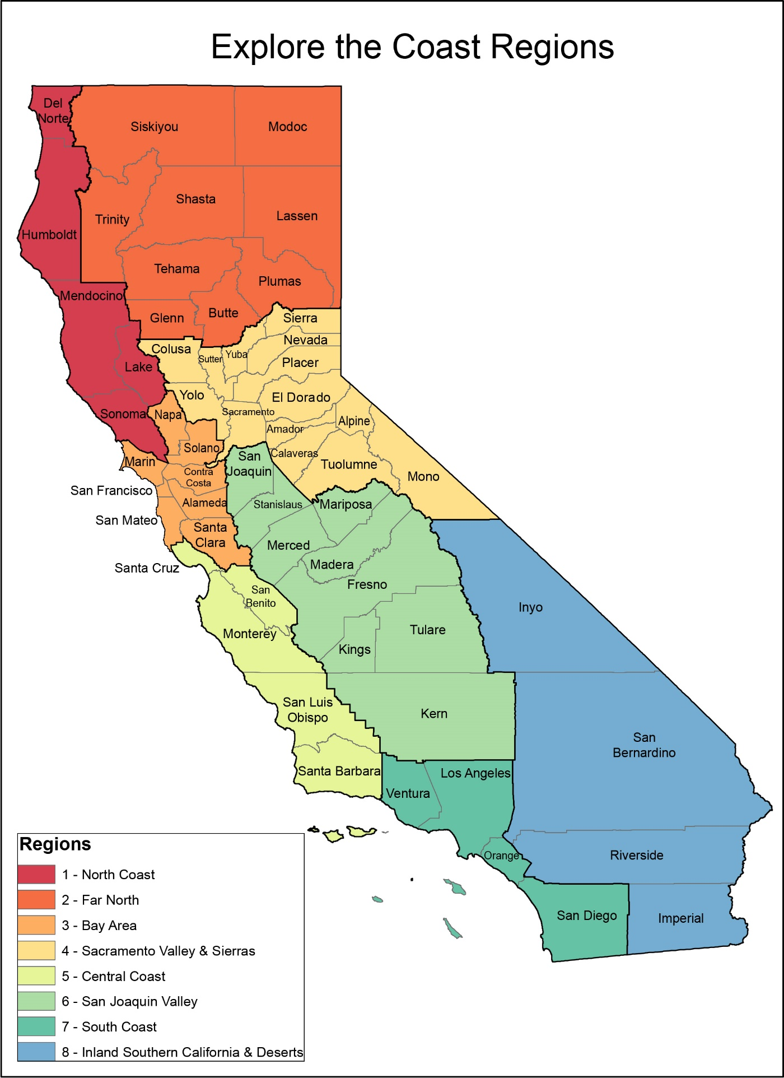
EXPLORE THE COAST GRANT APPLICATION
Contact Information
Organization*
Contact Person |  | Position/Title
Email |  | Phone
Address
Federal Tax ID#
*If project proponent uses a fiscal sponsor, the Organization should be entered as "[Fiscal Sponsor Name], fiscal sponsor for [Project Proponent]

Project Information
Project Name
Amount Requested (round up to nearest hundred) | $ |  | Total Project Cost | $
Start Date |  |  | End Date
Location Information
What specific facility(ies) will the project use/visit (e.g., Santa Monica Pier, Stinson Beach, Point Reyes National Seashore)?

Directions: Please read each question carefully and follow the instructions for your responses. Please keep your responses concise.
- Project Summary / Your Elevator Pitch! Summarize the proposed project, including the communities served, the total number of participants served by this grant, the primary participant activities, and the key objectives of your project. (Note: You will have the opportunity to describe your project in greater detail throughout this application) Please keep your response to 1-3 sentences.

- Participant Experience. Describe what participants will be doing throughout your program. What will the days, trips, activities look like? List each activity if your program consists of multiple parts. You may attach a programming schedule to support your response. Please limit your response to 3 paragraphs.

- ETC Priority Communities Served. The Explore the Coast grant program provides coastal experiences to communities who face challenges accessing or enjoying the coast. Please help us better understand which community(ies) the project will serve by answering the questions and filling out the table below to the extent you are able. Numbers can be approximate.

  - What is the total number of participants served by this grant:
  - What is the total number of participants from ETC Priority Communities:
  - What region of CA are your participants from, (please refer to the ETC Region Map on page 7 of the announcement for ETC region names):
  - Fill out the table below to identify the ETC priority community being served. This can include lower-income individuals and households, people with disabilities, people of color, English as a Second Language (ESL) communities, immigrant communities, foster youth, indigenous communities, and other historically excluded groups.)
ETC Priority Communities | Estimated Number of Participants
Low-income
People with Physical Disabilities
People with Cognitive or Emotional Disabilities
English as Second Language Learners
Foster and Homeless Youth
People of Color
Black
Asian/Pacific Islander
Latinx
Indigenous
Multi-Racial
Other ethnicities, please specify:
Other communities facing barriers accessing or enjoying the coast
People who were formerly incarcerated
Veterans
Other, please specify:

    - Provide a brief explanation for why the project is intended to serve the demographic(s) indicated in the tables above. Be specific on any challenges or difficulties the community(ies) faces in accessing or enjoying the coast and how the program will address those barriers. Please limit your response to 2 paragraphs.
    - Describe how your program includes all participants and considers differences in cultural and social backgrounds, past experiences, physical capabilities, knowledge, comfort levels, etc. when participating in program activities. Please limit your response to 2 paragraphs.
    - If you indicated in the tables above that your program will serve people with physical, cognitive, or emotional disabilities, provide additional details on how you will address the inclusion and accommodation of such participants. Please limit your response to 2 paragraphs.

- Long Term Positive Impacts Describe the ways in which the program is designed to have long-term positive impacts on participants. This can include leadership development opportunities, multi-year programs or programs that engage participants over multiple occasions, family or support system involvement, peer-to-peer mentorship, or solutions to overcome ongoing coastal access barriers. Please limit your response to 2 paragraphs.

- Explore the Coast Program Priorities Which Explore the Coast Program priorities does the project meet (check all that apply)? Briefly describe how the project meets each checked program priority. Please limit your respond to 1-3 sentences per priority.

☐ Provides an enjoyable experience at the coast.
☐ Reduces economic, physical, operational, or societal barriers to accessing or enjoying the coast.
☐ Inspires ongoing coastal resources stewardship ethic through active learning and interactive activities.

- Building and Fostering Connections with ETC Priority Communities. Please limit your responses for each following question to 1 paragraph in each sub question.

  - Describe how individuals from the community(ies) being served by the project are involved. This could include but is not limited to board members, management and non-management staff members, volunteers, or participation with program development.

  - How does the organization foster leadership development for the community served?
  - List your community partners and describe how they strengthen your organization.

- Project Scope. In the table below, briefly summarize the work involved for each of the provided tasks (project management, preparation, implementation, and project evaluation). A more detailed explanation of activities should be provided in answers to other application questions.

Project Scope | Description | Timeline  (MM/YR to MM/YR) | Milestones
Project Management | List specific tasks/activities related to the project and grant management.
Project Preparation | List specific tasks/activities related to the program preparation, such as participant outreach, coordination with project partners, staff training, other logistical activities.
Project Implementation | List the number and types of coastal experiences offered and clarify how many participants will be served by each type of coastal experience.

- Pandemic restrictions: Please describe any measures your project will have in place to adapt to potential pandemic-related health and safety restrictions.

- Project Evaluation. What are your organization's metrics and methods for measuring the project or program's success? Please limit your response to 1 paragraph.
Does your program conduct pre and post-surveys of participants?
☐ YES ☐ NO

- Budget. Provide a detailed breakdown and explanation of your project budget in whatever format you prefer. Include a separate line item for indirect costs. Please note that indirect costs cannot be more than 20% of the total grant amount. In addition, please answer the following questions and please limit your response to 1-3 sentences in for each.
  - Cost to Participants. Describe costs, if any, to participants in your program. Identify whether grant funding would enable the program to be free or subsidized.
  - Subsidies or Scholarships If your program provides participants subsidies or scholarships, please describe how participants are selected to receive them.
  - Other Program Support. In addition to Coastal Conservancy funding, what other funds or in-kind donations support your program?
- Applicant capacity. Briefly describe your organizational capacity to implement the project. When was your organization established? Will this grant fund an existing program or a new program? How large is your organization, and where is it based? Do you work with any partners on this project, and if yes, who are they? Please respond in no more than 2 paragraphs.
- Does your organization have grant writers, project managers, or a grant writing committee? (This question is meant to gauge your technical assistance needs and does not affect your application score)
☐ YES ☐ NO

- Nonprofit Organization. All nonprofit organizations need to complete our "Nonprofit Pre-Award Questionnaire" and provide a copy of your organization's IRS 501(c)(3) letter. Please note that the questionnaire is used to help us provide appropriate technical assistance to selected grantees and is not evaluated for project selection.

- Supplemental Documents (optional). Applicants are welcome to attach supplemental documents including 3 relevant photos (preferably as jpg), programs, and schedules with their application submission; these attachments should not exceed 10MB total. Relevant attachments should provide examples of the participant activities of the proposed project.

Application Checklist

☐ Completed Explore the Coast Grant application
☐ Supplemental Documents (optional, up to 10mb total): Photos, programs, schedules, etc.
☐ Completed nonprofit pre-award questionnaire
☐ Copy of your organization's IRS 501(c)(3) letter

Application Survey

After completing the ETC Grant application, please take some time to provide feedback on your experience as an applicant. Responses will be collected anonymously. The survey link can be accessed here. The Conservancy aims to improve our grant application process yearly and your feedback is valued.

Applicants from indigenous communities who are not federally-recognized tribes should work through a 501(c)(3) fiscal sponsor for their submittal.

