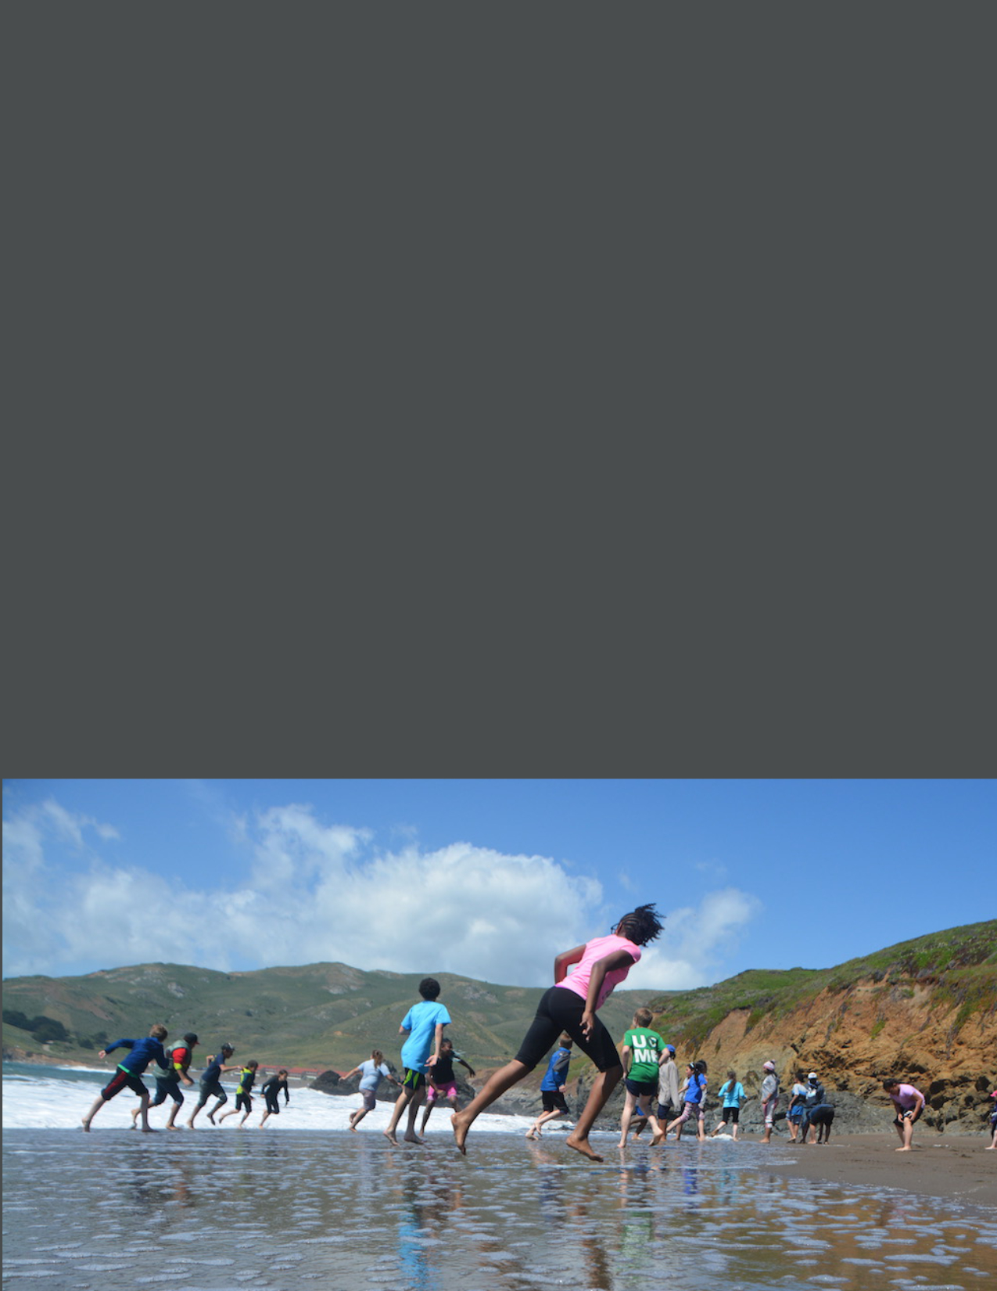
Application is attached to this announcement
Submit Application via email to grants@scc.ca.gov
Application Due Friday, March 11, 2022 at 5pm.
For questions only, email explorethecoast@scc.ca.gov
Please read the request for proposal thoroughly
2022 ANNOUNCEMENT
Released January 6, 2022

Explore the Coast Grant Renewal Application

Explore the Coast Grant Renewal Application

Renewal Application

This year, the California State Coastal Conservancy (Conservancy) is offering a shortened application process for organizations that currently have an Explore the Coast grant from the Conservancy and want to apply for funding to extend that existing grant. The goal of the renewal application is to offer a pathway for existing grantees to increase the award amounts and extend the terms of their existing grants without having to go through the burden associated with our annual grant program cycle. Organizations that do not have an existing Explore the Coast grant or organizations that want to apply for funding for a different program should use the standard Explore the Coast application, (WORD DOC DOWNLOAD) not the renewal application.

Renewal applicants should apply for existing projects that can be lengthened to be completed by February 2026. We anticipate that approximately $9 million will be awarded for this year’s grant round. Applicants may request a grant amount up to $100,000 for each year of the renewal. The Conservancy will base the size of the award on each project’s needs, its overall benefits, and on the extent of competing demands for funds. The purpose of this expedited renewal application is to reduce barriers associated with the grant application process. Grant renewal applicants who are selected for funding this year will be precluded from re-applying to the Explore the Coast Grant Program for additional funds until successful completion of renewed project or program.

Applications must be submitted via email to grants@scc.ca.gov by Friday, March 11, 2022 at 5 PM.

About Explore the Coast

Explore the Coast is a grant program of the Conservancy that funds public agencies, tribes, and nonprofit organizations for programs that facilitate and enhance the public’s opportunities to explore California’s coast and San Francisco Bay shoreline. The ability to experience the coast without fear of physical barriers, feelings of not belonging, or financial challenge, is crucial to how individuals cultivate their own lifelong connections with the coast. The Explore the Coast grant program seeks to provide enjoyable coastal experiences for people and communities who face challenges or barriers to accessing or enjoying the coast.

Funding for Explore the Coast grant renewals will come from a special one-time General Fund appropriation for the Explore the Coast Grant Program, which makes the total amount of available funding for ETC grants larger this year than in previous years. This year, the Conservancy has increased the maximum grant size, but we cannot predict the availability or amount of funding that will be appropriated in the State budget for future grant rounds. Due to the unpredictable nature of State fund appropriations, the Conservancy suggests grant applicants make the necessary preparations for limited funding opportunities in the future.

ETC Priority Communities may include but are not limited to lower-income individuals and households, people with disabilities, people of color, indigenous communities, immigrant communities, foster youth, and other historically excluded communities.

Projects should also meet one or more of the following priorities:
- Provides an enjoyable experience at the coast.
- Reduces economic, physical, operational, or societal barriers to accessing or enjoying the coast.
- Inspires ongoing coastal resource stewardship ethic through active learning and interactive activities.

Project Eligibility

Eligible Applicants: The Explore the Coast Grant Renewal Application is available to applicants with existing, active Explore the Coast grants that have demonstrated the ability to successfully implement their program.

Eligible Project Locations: Projects must involve visiting the coast of California or the shore of San Francisco Bay. The Conservancy is very interested in supporting programs that bring participants to the coast from throughout the state.

Eligible Projects: Only extensions of projects funded by an existing Explore the Coast grant are eligible for funding provided in this RFP. Organizations with an existing Explore the Coast grant who are seeking funding for a different program should use the standard Explore the Coast application, (WORD DOC DOWNLOAD) not this renewal application.

Ineligible Projects: Any project that is not currently funded by an Explore the Coast grant is ineligible to use this ETC Renewal Application. Instead, prospective applicants should refer to the eligibility section in the standard Explore the Coast application, (WORD DOC DOWNLOAD).

We encourage you to contact us if you have any questions regarding the renewal eligibility of your project. Additional information on how to reach us is located below.

Application

Application Submittal
The Explore the Coast grant renewal application is attached. Completed applications should be submitted via email as a word document to grants@scc.ca.gov. Applicants are welcome to attach up to 3 photos (preferably as JPEGs) with their application submission; these attachments should not exceed 10MB total. Relevant photos should provide examples of the participant activities of the proposed project.

Please be aware that all documents submitted to the Conservancy become public documents. The Conservancy will assume that submitted photos are permissible for use by the Conservancy unless the applicant clarifies otherwise.

Submission Date: Applications must be submitted to grants@scc.ca.gov by Friday, March 11, 2022 at 5 PM.

Webinar & Technical Assistance Office Hours

The Conservancy will hold a webinar on Tuesday, January 18, 2022, 11:00am-12:00pm to walk through the Explore the Coast Grant Renewal Application. Potential project applicants are encouraged to attend. The registration link for the webinar is here. We will also hold a webinar on Friday, January 21, 2022, 2 pm – 3 pm, registration here, to walk through the standard Explore the Coast Grant Program for those of you who are interested in a refresher. Both recorded webinars will be posted on scc.ca.gov a few days after they’re held.

In addition, the Conservancy will also a one hour long virtual Technical Assistance “Office Hour” session where SCC staff will answer specific grant questions and provide guidance with application preparation to potential applicants via a zoom meeting.
- Friday, February 4th, 2022, 3:00pm – 4pm Technical Assistance Office Hour link is here.

Contact Us For Assistance

Prospective applicants are encouraged to discuss their projects with Conservancy Project Managers prior to submitting their applications. Questions about the application process and potential projects may be directed to your existing Conservancy project manager or to explorethecoast@scc.ca.gov.

Applications must be submitted via email to grants@scc.ca.gov by Friday, March 11, 2022.

Helpful Resources

The following resources may be helpful for the preparation of your grant application.
Grant Writing Skills
In 2016, the Conservancy offered training to "Improve Your Grant Writing Skills." The recording of this webinar provides helpful guidance on how to write robust grant applications. We recommend you watch this video: https://youtu.be/bnR8KPTnWvc

Conservancy Grant Terms
Please review the sample grant terms before completing your application. Please note the insurance requirements for ETC grants. If the requirements result in higher insurance premiums for the applicant, this cost can be included in the grant budget.

Assistance with Incomplete Application Documents
The Conservancy does not automatically disqualify an application if it is missing a required element. In these cases, the Conservancy will request the missing information and provide a deadline for submittal. If multiple parts of the application are missing, it will be considered ineligible.

Strengths and Weaknesses

If your project does not receive a grant award, you can get "strengths and weaknesses" feedback based on the Project Selection Criteria once all decisions have been made. This feedback may be helpful to you in applying for funding in the future.

ETC GRANT RENEWAL APPLICATION

Organization:
Project Name:
Existing Explore the Coast Grant Number:
Contact Name:
Contact Email:
Contact Phone:

Amount Requested:
Total Project Cost:
Start Date:
End Date:
Work Completion Date of Existing Grant:

Directions: Please answer the questions below. Add lines below each heading as needed; renewal applications should be 1-2 pages total (not including photos). Please submit your renewal application and supporting documents to grants@scc.ca.gov.

- Project Description. Briefly summarize your proposed renewal project including the target communities, the total number of participants that will be served, the primary participant activities, key objectives of your project, and the estimated time the project will take.

- Project Update. Provide a brief update on the progress of your existing ETC grant, including when work will be completed. Describe how the project has changed since the original application, including changes to the project timeline, objectives, and deliverables as a result of COVID-19 or other factors.

- ETC Priority Communities. The Explore the Coast grant program provides coastal experiences to communities who face challenges accessing or enjoying the coast. Please help us to better understand which community(ies) the project is serving by answering the questions and filling out the table below to the extent you are able. Numbers can be approximate.

  - What is the total number of participants:
  - What is the total number of participants from ETC Priority Communities:
  - Fill out the table below to identify the ETC priority community being served. This can include lower-income individuals and households, people with disabilities, people of color, English as a Second Language (ESL) communities, immigrant communities, foster youth, and other historically excluded groups.
ETC Priority Communities | Estimated Number of Participants
Low-income
People with Physical Disabilities
People with Cognitive or Emotional Disabilities
English as Second Language Learners
Foster and Homeless Youth
People of Color
Black
Asian/Pacific Islander
Latinx
Indigenous
Multi-Racial
Other ethnicity, please specify:
Other communities facing barriers accessing or enjoying the coast
People who were formerly incarcerated
Veterans
Other, please specify:

- Draft Work Program. As a separate attachment, please provide a draft Work Program that addresses the period that would be covered by the new grant application. Your draft Work Program should be separate from your current work program but should follow the same format and include the tasks, deliverables, project schedule, and budget for the renewal period. The Conservancy’s Work Program template is linked here.

- Pandemic restrictions: Please describe any measures your project will have in place to adapt to potential pandemic-related health and safety restrictions.

- Photos (optional). Applicants are welcome to attach 3 relevant photos (preferably as jpgs) with their application submission; these attachments should not exceed 10MB total. Relevant photos should provide examples of the participant activities of the proposed project.

- Renewal Checklist. Please include the items on the following checklist with your renewal application submission.

 | Renewal Items
☐ | - Completed renewal application
☐ | - Updated draft work program
☐ | - Up to 3 photos (max total size of 10mb) to support your application (optional)

Application Survey

After completing the ETC Grant Renewal application, please take some time to provide feedback on your experience as an applicant. Responses will be collected anonymously. The survey link can be accessed here. The Conservancy aims to improve our grant application process yearly and your feedback is valued.

