CALIFORNIA STATE COASTAL CONSERVANCY

REQUEST FOR SERVICES:
TRIBAL CONNECTION TO
BALLONA WETLANDS RESTORATION PROJECT
BALLONA WETLANDS ECOLOGICAL RESERVE
CITY AND COUNTY OF
LOS ANGELES

January 11, 2022

Table of Contents

Table of Contents……………………………………………………………………………………..…………………………………………………2 List of Figures 3-5
Introduction 6
Deadline 6
Project Background 6
Resources for Project and Site Information 8
Scope of Services 9
Contract Budget 10
Requirement for Deliverables 10
Request for Services Requirements, Process, and Schedule 11
Contractor Selection Process 12
Proposal Ranking Criteria 12
Budget 12
Schedule 13
Information to Include in Submittal 13
Appendix 1 (Outline of typical Terms of the Contract) 15-26

List of Figures
Figure 1: Regional Map

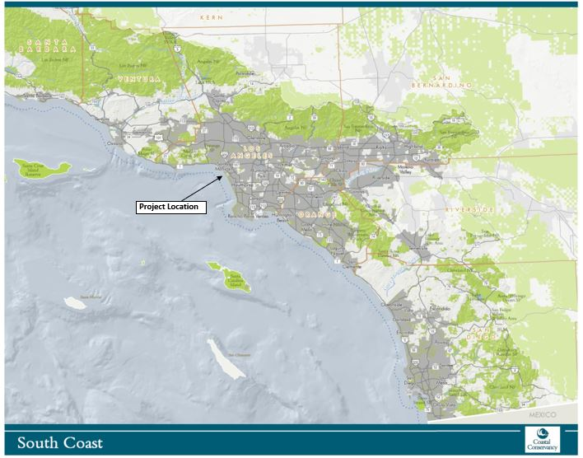

Figure 2: Watershed Map
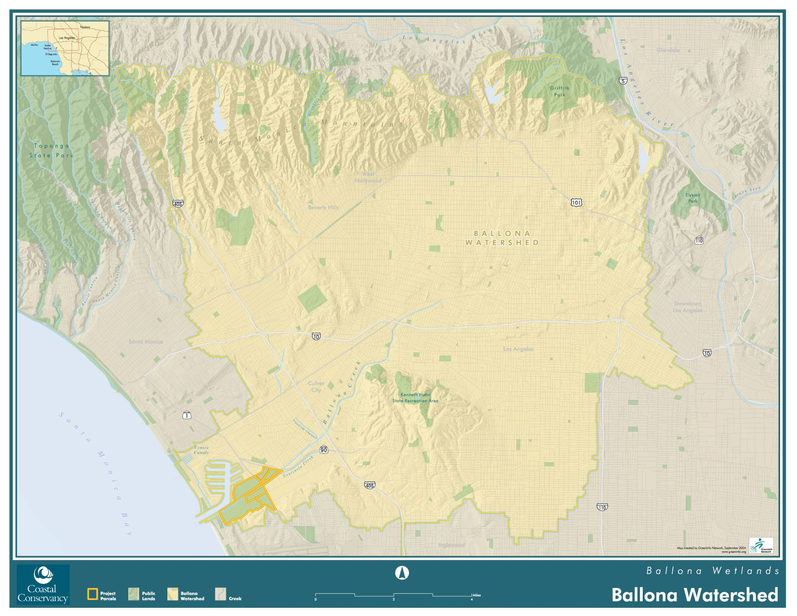

Figure 3: Site Map
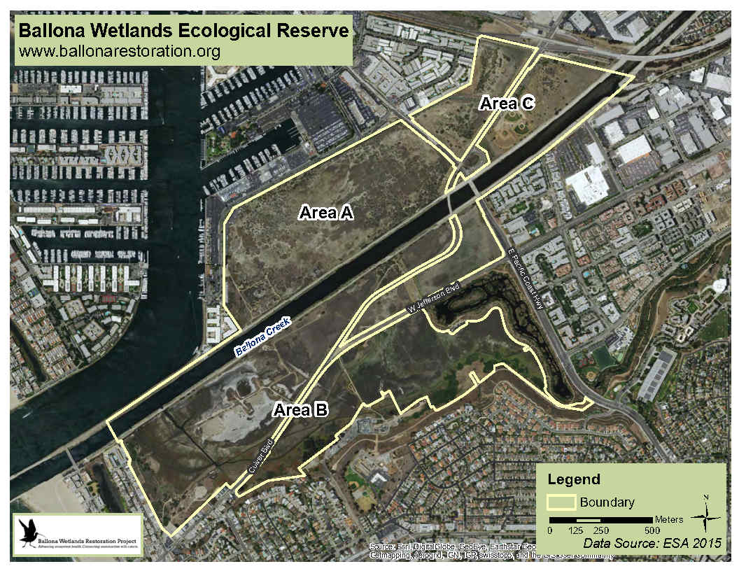

Introduction
The State Coastal Conservancy (Conservancy) requests the services of an expert in community engagement with tribal governments, tribal groups, and tribal community members (collectively "tribes") in Southern California to develop and implement participation from tribes regarding the Ballona Wetlands Restoration Project (Project), located in the Ballona Wetlands Ecological Reserve in the City of Los Angeles (Figure 1). The selected Contractor will help the Conservancy and the California Department of Fish and Wildlife (the landowner and project lead) to understand the concerns, experience, and priorities of the tribes to design and construct the Project in a way that is respectful of and beneficial to local tribes that have occupied the Project area from time immemorial. Staff will select a Contractor (or team) based on qualifications in response to this Request for Services (RFS).

This RFS is organized into six sections as follows:
- Section I: Introduction
- Section II: Project Description
- Section III: Scope of Services
- Section IV: Project Deliverables
- Section V: RFS Requirements, Process, and Schedule
- Section VI: Information to be Included in Submittal

Deadline
Submittals must be received by 12:00 p.m. (noon) on February 25, 2022.
An electronic copy (in PDF format; less than 20 Mb in size) of the submittal should be emailed to Megan Cooper, South Coast Regional Manager, State Coastal Conservancy, Megan.cooper@ scc.ca.gov.

An acknowledgment that the Conservancy has received the submittal will be sent by email by 5:00 p.m. on the same day. If your submittal is not acknowledged by then, please call Megan Cooper at 510-286-4162.

Project Background
The Ballona Wetlands Ecological Reserve (Reserve) is the largest coastal wetland complex in Los Angeles County. The Project will enhance and establish native coastal wetlands and upland habitat on 566 of the Reserve's 577 acres south of Marina del Rey and east of Playa del Rey, restoring ecological function to currently degraded wetlands and providing a critical buffer against the effects of sea-level rise. The Project's objectives focus on restoring wetland and other ecological functions within the Reserve, maintaining existing levels of flood risk management provided by the Ballona Creek channel and levee system and restoring and improving public access for compatible recreational and educational opportunities limited within the reserve. The Project is led by the California Department of Fish and Wildlife (DFW) and supported by the Conservancy. More information about the Project, including the certified EIR, can be found at this website: https://wildlife.ca.gov/Regions/5/Ballona-EIR.

The land of the Ballona Reserve is the ancestral homeland of the Tongva/ Kizh/ Gabrieleno people. Descendants of the indigenous people of this region disagree over the appropriate term. Human occupation of the Ballona Reserve area dates to approximately 8,000 to 7,000 years ago. Before European colonization, the Tongva/ Kizh/ Gabrieleno people occupied a diverse area that included the watersheds of the Los Angeles, San Gabriel, and Santa Ana rivers; the Los Angeles basin; and the islands of San Clemente, San Nicolas, and Santa Catalina. The village known as Guaspet, or Guasna, may have been located in the project vicinity. Two archaeological sites with components dating to the Spanish era are in the Ballona Reserve and may be the location of Guaspet, although this has not been confirmed. Because of the historical activity and habitation near the Ballona Reserve, the Native American Heritage Commission considers the site culturally sensitive.

Although there is great potential for ecological and cultural restoration at the site, it is also a site of serious trauma for local tribes because of the recent desecration of cultural resources nearby. During the construction of Playa Vista in 2007, immediately adjacent to the Ballona Reserve, the remains of more than 1,000 indigenous people were disturbed. Many of these remains were eventually reburied nearby. The Native American Heritage Commission notified Conservancy staff that the "Playa Vista Project constitutes the greatest destruction of Native American burial sites and cultural resources in recent California history." This was an incredibly traumatic experience for the native community, and tribal members have raised concern that something similar could occur during the implementation of the Project. The sensitive nature of the site and past experiences must be addressed through this tribal engagement service.

Now that the EIR is certified, DFW is beginning work on the project's final design, engineering, and permitting phase. The final design, engineering, and permitting phase includes new studies, modeling, engineering, design, and permit applications. The level of design contained in the EIR is considered "30% design," and during the final design and engineering phase DFW will refine the designs to a level of "90% design". Through this RFS, the Conservancy seeks input on the Project design to consider tribal concerns, experience, and priorities in the final design and permit applications. The list of necessary permits can be found at the following link:https://scc.ca.gov/webmaster/ftp/pdf/sccbb/2021/2105/20210527Board05_Ballona_Wetlands_Ex7.pdf

Tribal input and expertise are required for this project development stage and permit processing. The professional services provided through this contract will help the Conservancy and DFW incorporate tribal expertise into the project at the high level of quality that tribes deserve. Mitigation measures identified in the EIR that will impact tribes and require tribal engagement include MM CR-1 (requiring a Cultural Resources Monitoring Plan), CR-2, CR3, and CR-6. Laws requiring tribal engagement include Section 21084.1 of CEQA and Section 15064.5 of the CEQA Guidelines; Public Resources Code §5097.9 regarding the Native American Heritage Commission; Section 106 of the National Historic Preservation Act regarding consultation with the Army Corps of Engineers; California Health and Safety Code §7050.5; Public Resources Code §5097.9; Public Resources Code Section 5097.98; Public Resources Code §5097.991; the LA County General Plan; the City of LA General Plan; NEPA rules and CEQ guidance regarding environmental justice; and Executive Order 12898 regarding environmental justice.

Various agency policies also require tribal consultation, including DFW's Tribal Communication and Consultation Policy; State Coastal Conservancy's Tribal Consultation Policy, and Coastal Commission's Tribal Consultation Policy.

There are seven California tribes on the Native American Heritage Commission's (NAHC) contact list for the Project. Those tribes are:

- Gabrieleño Band of Mission Indians - Kizh Nation
- Gabrieleño/Tongva San Gabriel Band of Mission Indians
- Gabrielino /Tongva Nation
- Gabrielino Tongva Indians of California Tribal Council
- Gabrielino-Tongva Tribe
- Santa Rosa Band of Cahuilla Indians
- Soboba Band of Luiseño Indians

On April 27, 2021, and August 24, 2021, the Conservancy contacted these tribes to inform them of the Project, offer government-to-government consultations, and seek their input and engagement on the project. The above tribes must be invited to participate in the Project and be provided financial compensation and support. Other tribal and indigenous-led organizations that represent tribal interests should also be invited to participate.

Resources for Project and Site Information
- Information about the Project, including the draft and final EIR, can be found at this link: https://wildlife.ca.gov/Regions/5/Ballona-EIR.

- The Conservancy's staff recommendation for funding the project's final design, engineering, and permitting can be found here: May 27 – Sacramento/Teleconference.

- The recording of the Conservancy's May 27, 2021 Board meeting, at which the funding for the final design and engineering of the Project was approved, can be found here: Recording of May 27 Meeting – Part 1; Recording of May 27 Meeting – Part 2. The public testimony on the Project can be heard on these recordings.

Scope of Services
The Conservancy has developed the Scope of Services below to provide the Contractor with an understanding of our desired outcomes. However, we seek the Contractor's expertise to guide the approach and tasks for this RFS. If you do not agree with the proposed Scope of Services below, please explain why and propose the new or revised tasks in your proposal (see Section VII below). The Contractor will be responsible for developing and completing the following tasks (not necessarily in this order):

TASK 1: Identify and contact interested tribal governments, tribal groups, and tribal community members. The Contractor will create a list of tribes and tribal/indigenous organizations, with contact information, that could have an interest in the project. The Contractor will contact each of the potentially interested groups and engage them in the project if they are interested. This task could involve initial meetings with tribes.

TASK 2: Subcontract with tribes to financially support their participation in the project. The Contractor will subcontract with interested tribes or tribal groups and financially compensate them for participating and providing their expertise in the project. The Contractor will work with each tribal subcontractor to develop the scope and budget for each group's participation.

TASK 3: Develop and facilitate a Tribal Advisory Committee. The Contractor will develop a Tribal Advisory Committee to advise DFW on the final design and required permit applications for the Project. The Contractor will work with interested tribes to establish the committee and develop the committee's scope of engagement and involvement. The scope will be guided by the tribes and structured to work for each organization. Tasks could include but are not limited to:
- Develop a Tribal Advisory Committee for the Project. Identify and contact tribal members who are interested in participating in the committee. The committee members should represent tribes with an ancestral homeland or connection that includes the Project area.
- Conduct site visits with committee members to learn more about the site and the Project.
- Organize and facilitate meetings between committee members and Project decision-makers such as DFW, Conservancy, and/or permitting and regulatory agencies to provide input on documentation related to required permit applications;
- Facilitate conversations among committee members to discuss the Project and develop tribally-led recommendations for DFW; and
- Communicate regularly with committee members and Project leads between meetings.

TASK 4: Develop and facilitate engagement with the tribal community. The Contractor will develop engagement for the broader tribal community to learn about and provide input on the Project. Tasks could include but are not limited to:
- Develop and implement a healing process around the exhumation of tribal ancestors that occurred during the construction of the Ballona Wetlands Freshwater Marsh;
- Conduct site visits with the tribal community to learn more about the site, traditional uses of the site, vision for tribal use of the site; and
- Facilitate meetings among tribal community members to discuss the Project and develop tribally-led recommendations for DFW.

TASK 5: Document recommendations from tribes. The Contractor will document the recommendations from the Tribal Advisory Committee (Task 3) and the tribal community members (Task 4) in a manner that can be shared with Project decision-makers, such as DFW, Conservancy, and/or permitting and regulatory agencies, and will inform the Project design, engineering, and permitting of the Project. Please note that deliverables created through this process are Conservancy-owned, public documents and will be part of the public record. The Contractor should work with tribes to develop documentation that is sensitive to tribal concerns over confidential information. Documentation of tribal input should include:
- Written recommendations. The Consultant will develop a set of written recommendations that summarize the input from Tasks 3 and 4 and will share those recommendations with the Project decision-makers. The recommendations should inform the project's engineering, design, permitting, and long-term management.

Additional documentation from Tasks 3 and 4 could include but is not limited to:
- Written meeting notes;
- Recorded stories or notes;
- Verbal communications directly to decision-makers that are not recorded;
- Photos; and
- Drawings or maps.

Contract Budget
The budget amount for the contract is negotiable. This includes the amount for the subcontracts. See the Budget section beginning on Page 12 for more information.

Requirements for Deliverables
- Deliverables must be provided in electronic format. All drafts and final documents must be provided in PDF format to be easily shared and in Word, if requested. All text will be printed single-spaced, double-sided, no smaller than size 12 font, using a conventional report (11-inch by 8.5-inch) format, except for any large plan (11-inch by 17-inch) format pages. Final major deliverables must be provided in hard copy in addition to electronic format. All hardcopy documents must be printed on recycled paper.
- Project maps, graphics, and drawings will be delivered in hard copy and PDF format.
- Some drawings and other figures may be presented in the large poster format for public display.
- Deliverables will be quality checked by the Contractor and reviewed by technical and copy editors to ensure concise and understandable. Final drafts and final versions shall be reviewed and approved by the Conservancy staff.

Request for Services Requirements, Process, and Schedule
This section outlines the requirements that must be met by the Contractor to be considered for the proposed contract, the RFS process, and the schedule for Contractor selection.

Detailed information on the required form and content of the submittal is provided in Section VII.

General Requirements

- Potential Contractors should have significant, established experience in tribal engagement in Southern California.

- The Contractor shall be able to furnish all necessary labor, facilities, and materials to perform the tasks listed above. If needed, the Contractor may subcontract portions of this work to deliver the requested services.

- The Contractor will be available to meet with the Conservancy and other key stakeholders regularly and will keep the Conservancy apprised of progress.

- The Contractor and any key staff must have demonstrated organizational skills and a proven track record of delivering work products on time and within budget.

- The Contractor and any key staff must have excellent interpersonal, written, and oral communications skills.

- The Contractor must agree to the Typical Conservancy Contract Language (See Appendix 1). Please review this language carefully.

- The Contractor will be paid in arrears and have 10% withheld from each invoice. The Contractor will be paid for its actual time and expenses up to the amount provided for each task in the final project budget. The Contractor should anticipate that ten percent (15%) will be withheld on each task until all work for that task is completed to the satisfaction of the Conservancy. The Conservancy must also approve all interim work products before payment. Each invoice shall include a progress report summarizing accomplishments related to each task.

Contractor Selection Process
The Contractor selection process consists of submitting a proposal, initial ranking of proposals, an invitation to an interview for the top-ranked firms, and the final selection of the Contractor. The Contractor selection committee will consist of up to three Conservancy staff and two outside reviewers. The selection committee will rank the proposals based on the Proposal Ranking Criteria below. The final ranking will be based on a combination of the written submittal and an interview.
The Conservancy may request supplemental information during the selection process. If supplemental information is requested, all submitters will be notified of the request and will have the opportunity to submit the requested information.

Proposal Ranking Criteria
Contractor Qualifications, including:
- Specialized qualifications for the services to be performed;
- Experience with similar projects;
- The Contractor's management approach includes staying on schedule and within budget.
Approach and Project Understanding, including:
- The appropriateness of the proposed project approach and philosophy;
- The Contractor's ability to develop a project approach that will support the Conservancy and DFW in their goal of informing the final design and engineering of the Project; and
- The clarity and completeness of the written submittal.
Project Team, including:
- Education and experience of any key personnel;
- Project team members have worked together on similar projects; and
- Key staff is dedicating the appropriate amount of time to the project tasks.
Other Considerations:
- Tribal engagement experience: Preference will be given to a Contractor that has demonstrated experience engaging with Southern California tribes.
- Southern California Office: Preference will be given to firms that do business and have an office located in Southern California.
- A commitment of Project Lead: The Contractor will appoint a project lead who will be responsible for all aspects of the work contracted for and who will report and be in close communication with the Conservancy project manager.

Budget
The Conservancy will attempt to negotiate a contract with the highest ranked Contractor at compensation that the Conservancy determines is fair and reasonable to the State of California. If the Conservancy is unable to do so, negotiation with that Contractor will be terminated, and negotiations will then proceed in the same manner with the following Contractor on the list in order of ranking. If the Conservancy is unable to negotiate a satisfactory contract with any of the selected Contractors, the Conservancy may select additional firms and continue the negotiation process.

Schedule

TASK | DATE
Release Request for Services | Jan 11, 2022
Written Submittal Due | Feb 25, 2022
Evaluation and ranking by Conservancy selection committee | Feb 28, 2022 – Mar 11, 2022
Notify applicants of invitation to interview | March 14, 2022
Conduct Interviews | Mar 21 – Apr 1, 2022
Conservancy Board Meeting | March 24, 2022
Notify applicants of the selected firm | April 8, 2022
Negotiate Scope of Work and Budget with selected Contractor | Apr 11 – 15, 2022
Finalize and Execute Contract | Apr 18 – 22, 2022
Begin Work | Apr 25, 2022

Information to be Included in Submittal

Qualifications (up to 3 pages)
Please describe your firm's qualifications as they apply to this RFS. This section should include a brief overview of your firm (or team if multiple Contractors are working together), including relevant experience and areas of expertise. Include your firm's unique qualifications to perform on this project.

Approach and Project Understanding (up to 6 pages)
Please describe the proposed project's approach, methods, and timing that outlines the major tasks and deliverables. The Contractor should propose an approach to engage tribes and tribal communities to inform the Project final design, engineering, and permitting. If you do not agree with the proposed Scope of Services in Section III of this RFS, please explain why and propose a new scope. Indicate how the Conservancy and DFW will be kept informed of progress and how the Conservancy will obtain feedback. Please describe your:

- Scope of work, based on the tasks described in Section III of this RFS – Scope of Services, and your understanding of the project. Modify the proposed Scope of Services if needed and explain why. The Scope should include key milestones, meetings, deliverables, and schedules.
- Understanding of the Ballona Wetlands Restoration Project.
- Understanding of the concerns and issues raised by members of the tribal community that should be addressed during the final design and phase of the Project.
- Understanding of local tribes interested in the project and/or who see the site as a culturally-significant site.
- Process for assuring the project cost is within the scope and budget and completed on time.

Project Team (up to 3 pages)
Include an organizational chart with the names and titles of the key staff proposed for this project and the percentage of each staff member working on the project. Specify whether/which team members have worked together on similar projects in the past and provide a brief listing of the projects. Indicate the length of time any key staff has been with the firm.

Resumes (up to 4 pages)
Brief resumes for up to four key staff proposed for this project. Include information about relevant previous projects and technical/managerial skills. Resumes should only be provided for key staff. Individual resumes must be no more than 1 page in length.

Examples of Relevant Project Work (up to 4 pages)
Examples of relevant project work for the Contractor should be limited to 1 page per project, with no more than four projects included. The project descriptions must contain the following information:
  - Amount of contract to Contractor;
  - Project description/background;
  - A specific description of the role for the Contractor on the project;
  - Names of staff who worked on the project and their roles; and
  - Client name and contact information.

References
Contact information for three references substantiates the Contractor's ability to meet project deadlines and deliver products on time and within budget.

APPENDIX 1

Typical Conservancy Contract Language

Terms of Contract Early Termination and Suspension

This contract shall take effect when signed by both parties. This contract may be signed using an electronic process specified by the Conservancy.

The term of this contract is from its effective date through ("termination date"). However, all work shall be completed by ("the completion date"). [Must be three months earlier than termination date.]

The term of this contract is based on the current level of funding available for the services to be provided under this contract. If additional funding is authorized, the parties anticipate that the term of the contract will be extended and the scope of work will be revised by amendment.

The Conservancy may terminate this contract for any reason by providing the contractor with seven days' notice in writing. During the term, the Conservancy may also suspend the contract upon written notice. In either case, upon receipt of the notice of termination or suspension, the contractor shall immediately stop work under the contract and take whatever measures are necessary to prevent further costs to the Conservancy under this contract. The Conservancy shall be responsible for any reasonable and noncancelable obligations incurred by the contractor in the performance of this contract up to the date of notice to terminate or suspend, but only up to the unpaid balance of total funds authorized under this contract. Any notice suspending work under this contract shall remain in effect until further written notice from the Conservancy authorizes work to resume.

On or before the date of termination of the contract under this section, the contractor shall provide the Conservancy with all work, material, data, information, and written, graphic, or other work produced or developed under this contract (whether completed or partial), inappropriate, readily useable form.

The contractor shall include in any contract with any subcontractor retained for work under this contract a provision that entitles the contractor to suspend or terminate the contract with the subcontractor for any reason on written notice and the same terms and conditions specified in this section.

Work Product

The contractor hereby assigns to the Conservancy, and the Conservancy accepts the assignment of all rights and interest in all material, data, information, and written, graphic, or other work produced under this contract, including, without limitation, any right to copyright, patent, or trademark the work.

The contractor shall include in any contract with a third party for work under this contract a provision that preserves the rights created by the first paragraph of this section and identifies the Conservancy as a third-party beneficiary of that provision.

Pursuant to Government Code section 7550, any document or written report that is produced under this contract at a cost of greater than $5,000 shall contain a separate section disclosing all contracts and subcontracts related to the production of the document or written report, including the contractor or subcontractor name, contract number, and the total amount of the contract or subcontract.

In any work products produced pursuant to this contract, the contractor shall state, in a prominent location, that the work product was prepared on behalf of and paid for by the Conservancy.

The contractor shall provide similar acknowledgment in any public presentation or publication which describes or utilizes any work product produced pursuant to this contract. Any reference on the contractor's website to this contract's work products shall state that the work product was prepared on behalf of and paid for by the Conservancy and shall include a link to the Conservancy's website. The contractor shall impose the obligations described in this paragraph on its subcontractors and shall include a similar provision to this paragraph in any agreement for work pursuant to this contract.

Cost and Disbursements

The total amount of funds disbursed under this contract shall not exceed $ [Amount in words]. The amount encumbered by this contract is based on the current level of funding available for the services under this contract. If additional funding is authorized, the parties anticipate that the total amount of funding will be increased and the budget revised by amendment to this contract.

The Conservancy shall make disbursements to the contractor based on services rendered and costs incurred to date, less five percent, (10%) upon satisfactory progress in accordance with schedules, budgets, and other provisions of this contract, and upon submission of a "Request for Disbursement" form (available from the Conservancy), which shall be submitted no more frequently than monthly but no less frequently than quarterly. The Conservancy shall disburse the five percent withheld upon completion of all tasks to the satisfaction of the Conservancy and upon the submission of a final Request for Disbursement.

If the Conservancy retains the funds withheld for 60 days or more beyond completion of the contractor's services, the contractor may request in writing that the Conservancy place the amounts withheld in an interest-bearing escrow account in a state or federally chartered bank in California, in accordance with California Public Contract Code section 6106.5. However, if the contractor avails itself of this option, it must make the same option available, with respect to amounts that the contractor withholds from the subcontractors to any subcontractors performing more than five percent of the monetary value of the work. The escrow agreement(s) shall be substantially in the form prescribed by Public Contract Code section 6106.5(f).

Services shall be billed at no more than the standard billing rate for the following personnel of the contractor and its subcontractors:

Principal $ /hr.
Senior Associate $ /hr.
Associate $ /hr.
XXX, etc. $ /hr. Secretarial services $ /hr.

If additional funding is authorized for the work under this contract and the term and total funding are increased by amendment, the contractor's hourly rates may be increased by amendment to reflect a reasonable increase in market rates for similar services.

The Conservancy will reimburse the contractor for direct expenses necessary to the provision of services under this contract when documented by appropriate receipts. The Conservancy will reimburse travel and related expenses at actual costs not to exceed the rates provided in Title 2, Division 1, Chapter 3, Subchapter 1, Article 2 of the California Code of Regulations, except that reimbursement may be in excess of these rates upon provision of documentation that rates in compliance are not reasonably available to the contractor. Reimbursement for the cost of operating a private vehicle shall not, under any circumstance, exceed the current rate specified by the State of California for unrepresented state employees as of the date the cost is incurred. All travel other than automobile travel or by public transit (the latter of which is strongly encouraged) within the [City/County of ], must be approved in advance by the Executive Officer of the Conservancy ("the Executive Officer").

The Conservancy will reimburse the contractor at cost for other necessary expenses if those expenses are reasonable in nature and amount, taking into account the services provided and other relevant factors.

[Subject to negotiation: No overhead or indirect expenses of the contractor or its subcontractors will be reimbursed. {or} Overhead or indirect expenses of the contractor and its subcontractors may be reimbursed at no more than percent of the total amount invoiced for labor costs.]

Each Request for Disbursement submitted by the contractor must include the contractor's name and address, the number of this contract, the contractor's authorized signature, the date of submission, the total amount of costs incurred for the period, a brief description of the services rendered and work products completed, and an itemized description, including time, materials and expenses incurred, of all work done for which disbursement is requested. The Request for Disbursement must also indicate itemized cumulative expenditures to date, expenditures during the reporting period, and the unexpended balance of contract funds. Each Request for Disbursement shall be accompanied by:

- All receipts and any other source documents for direct expenditures and costs incurred by the contractor.

- Invoices from subcontractors that the contractor engaged to complete any portion of the work funded under this contract and any receipts and any other source documents for costs incurred and expenditures by any such subcontractor unless the Executive Officer makes a specific exemption in writing.

- A supporting progress report summarizing the current status of the tasks under this contract and comparing it to the status required by the "SCOPE OF CONTRACT" section, above, including written substantiation of completion of the portion of the tasks for which disbursement is requested.

The contractor shall submit a final Request for Disbursement within thirty days after the completion date provided in the "TERM OF CONTRACT, EARLY TERMINATION, AND SUSPENSION" section above.

As required by this section, the contractor's failure to submit a Request for Disbursement and supporting documents will relieve the Conservancy of its obligation to disburse funds to the contractor until the contractor corrects all deficiencies.

Expenditure of Funds and Allocation of Funding Among Budget Items

The total amount of this contract may not be increased except by amendment to this contract. The contractor shall expend funds in the manner described in the budget included under the "SCOPE OF CONTRACT" section above. The allocation of funds among the items in the budget, other than overhead and indirect costs, may vary by as much as ten percent without approval by the Executive Officer, provided that the contractor submits a revised budget to the Executive Office prior to requesting disbursement based on the revised budget. Any difference of more than ten percent, and any deviation that shifts funds from approved budget items into an overhead or indirect costs category, must be identified in a revised budget approved in advance and written by the Executive Officer. The Conservancy may withhold payment for changes in particular budget items that exceed the amount allocated in the approved budget by more than five percent and which have not received the approval required above. Any increase in the funding for any particular budget item shall mean a decrease in the funding for one or more other budget items unless there is a written amendment to this contract.

Indemnification and Hold Harmless

The contractor shall be responsible for, indemnify and save harmless the Conservancy, its officers, agents, and employees from any and all liabilities, claims, demands, damages, or costs, including without limitation litigation costs and attorneys' fees, resulting from or arising out of the willful or negligent acts or omissions of the contractor, its officers, agents, subcontractors and employees, or in any way connected with or incident to this contract, except for the active negligence of the Conservancy, its officers, agents or employees. The contractor's duty to indemnify and save harmless includes the duty to defend as set forth in Civil Code section 2778.

The contractor waives any and all rights to any type of express or implied indemnity or right of contribution from the State, its officers, agents or employees, for any liability resulting from, growing out of, or in any way connected with or incident to this contract.

The obligations in this "INDEMNIFICATION AND HOLD HARMLESS" section shall survive termination of this contract.

Insurance

Throughout the term of this contract, the contractor shall procure and maintain insurance, as specified in this section, against claims for injuries to persons or damage to property that may arise from or in connection with any activities by the contractor or its agents, representatives, employees, or subcontractors associated with the project undertaken pursuant to this contract.

- Minimum Scope of Insurance. Coverage shall be at least as broad as:

  - Insurance Services Office ("ISO") Commercial General Liability coverage (occurrence Form CG 0001 or comparable).

  - Automobile Liability coverage - ISO Form Number CA 0001, or comparable (covering "Any Auto" or Owned, Hired and Non-owned autos).

  - Workers' Compensation insurance as required by the Labor Code of the State of California.

- Minimum Limits of Insurance. The contractor shall maintain limits no less than:

a. General Liability:  (Including operations, products and completed operations, as applicable) | $2,000,000 per occurrence for bodily injury, personal injury and property damage. If Commercial General Liability Insurance or other form with general aggregate limit is used, either the general aggregate limit shall apply separately to the activities under this contract or the general aggregate limit shall be twice the required occurrence limit.
b. Automobile Liability: | $1,000,000 per accident for bodily injury and property damage.
c. Worker's Compensation: | As required by law with Employer's Liability of no less than $1,000,000.

- Deductibles and Self-Insured Retentions. Any deductibles or self-insured retentions must be declared and approved by the Executive Officer.

- Required Provisions Concerning the Conservancy and the State of California.

  - Each insurance policy required by this section shall be endorsed to State that coverage shall not be canceled by either party, except after thirty days' prior written notice by first class mail has been given to the Conservancy or, in the event of cancellation of coverage due to nonpayment, after ten days' written notice to the Conservancy. The contractor shall notify the Conservancy within the earlier of: two days following the contractor's receipt of any notice of cancellation, non-renewal or material change that affects the required insurance; or five business days before the effective date of any cancellation, non-renewal or material change that effects required insurance coverage.

  - The contractor hereby grants to the State of California, its officers, agents, employees, and volunteers, a waiver of any right to subrogation which any insurer of the contractor may acquire against the State of California, its officers, agents, employees, and volunteers, by virtue of the payment of any loss under such insurance. The contractor agrees to obtain any endorsement that may be necessary to effect this waiver of subrogation, but this provision applies regardless of whether or not the contractor has received a waiver of subrogation endorsement from the insurer.

  - The general liability, automobile liability, and vessel policies (if any) are to contain, or be endorsed to contain, the following provisions:

    - The State of California, its officers, agents and employees are to be covered as additional insureds, but only with respect to activities conducted relative to this contract. The additional insured endorsements are to be provided.

    - For any claims related to this contract, the contractor's insurance coverage shall be primary insurance as respects the State of California, its officers, agents and employees, and not excess to any insurance or self-insurance of the State of California.

    - The limits of the additional insured coverage shall equal the limits of the named insured coverage regardless of whether the limits of the named insurance coverage exceed those limits required by this agreement.

  - Coverage shall not extend to any indemnity coverage for the active negligence of the additional insured in any case where an agreement to indemnify the additional insured would be invalid under Subdivision (b) of section 2782 of the Civil Code.

- Acceptability of Insurers. Insurance is to be placed with insurers admitted to transact business in the State of California and having a Best's rating of "B+:VII" or better or, in the alternative, acceptable to the Conservancy and approved in writing by the Executive Officer.

- Subcontractors. The contractor shall include all subcontractors as insureds under its policies or shall require each subcontractor to provide and maintain coverage consistent with the requirements of this section.

- Verification of Coverage. The contractor shall furnish the Conservancy with original certificates and amendatory endorsements, including the required additional insured endorsements, effecting coverage required by this clause. All certificates and endorsements are to be received and approved by the Executive Officer before work commences. The Conservancy reserves the right to require complete, certified copies of all required insurance policies, including endorsements affecting the coverage, at any time.

- Premiums and Assessments. The Conservancy is not responsible for premiums and assessments on any insurance policy.

- Claims Made. If errors-and-omissions coverage is written on a claims-made form:

  - The "Retro Date" must be shown, and must be before the date of this contract or the beginning of work.

  - Insurance must be maintained and evidence of insurance must be provided for at least five years after completion of the work.

  - If coverage is canceled or non-renewed, and not replaced with another claims-made policy form with a "Retro Date" prior to the effective date, the contractor must purchase "extended reporting" coverage for a minimum of five years after completion of the work under this contract.

  - A copy of the claims reporting requirements must be submitted to the Executive Officer for review.

Nondiscrimination

During the performance of this contract, the contractor and its subcontractors shall not unlawfully discriminate against, harass, or allow harassment against any employee or applicant for employment because of sex, race, color, ancestry, religious creed, national origin, ethnic group identification, physical disability (including HIV and AIDS), mental disability, medical condition, genetic information, gender, gender identity, gender expression, marital status, age, sexual orientation, or military and veteran status (Government Code section 12940). The contractor and its subcontractors also shall not unlawfully deny a request for or take unlawful action against any individual because of the exercise of rights related to family-care leave (Government Code sections 12945.1 and 12945.2). The contractor and its subcontractors shall ensure that the evaluation and treatment of their employees and applicants for employment are free of such discrimination, harassment and unlawful acts.

Consistent with Government Code section 11135, the contractor shall ensure that no one, on the basis of race, national origin, ethnic group identification, religion, age, sex, sexual orientation, color, genetic information, or disability, is unlawfully denied full and equal access to the benefits of, or is unlawfully subjected to discrimination under, the work funded by the Conservancy under this contract.

Pursuant to Government Code section 12990, the contractor and its subcontractors shall comply with the provisions of the Fair Employment and Housing Act (Government Code section 12900 et seq.) and the applicable regulations (California Code of Regulations, Title 2, section 7285.0 et seq.). The regulations of the Fair Employment and Housing Commission regarding contractor Nondiscrimination and Compliance (Chapter 5 of Division 4 of Title 2 of the California Code of Regulations) are incorporated into this contract by this reference.

The contractor and its subcontractors shall give written notice of their obligations under this clause to labor organizations with which they have a collective bargaining or other agreement. This nondiscrimination clause shall be included in all subcontracts entered into by the contractor to perform work provided for under this contract.

Nondiscrimination in Provision of Benefits- Domestic Partners

The contractor certifies that it is in compliance with Public Contract Code section 10295.3, which prohibits discriminating in the provision of benefits between
employees with spouses and employees with domestic partners, or between employees with spouses or domestic partners of different sex and employees with spouses or domestic partners of the same sex, or between same-sex and different-sex domestic partners of employees or between same-sex and different-sex spouses of employees.

Audits/Accounting/Records

The contractor shall maintain financial accounts, documents, and records (collectively, "records") relating to this contract, in accordance with the guidelines of "Generally Accepted Accounting Principles" published by the American Institute of Certified Public Accountants. The records shall include, without limitation, evidence sufficient to reflect properly the amount, receipt, deposit, and disbursement of all funds related to the services that the contractor is providing, and the time and report. The contractor shall maintain adequate supporting records in a manner that permits tracing of transactions from the invoices to the accounting records and to the supporting documentation.

The contractor shall retain these records for three years following the date of final disbursement by the Conservancy under this contract, regardless of the termination date. The records shall be subject to examination and audit by the Conservancy and the Bureau of State Audits during this period.

Additionally, the Conservancy or its agents may review, obtain, and copy all records relating to the performance of the contract. The contractor shall provide the Conservancy or its agents with any relevant information requested and shall permit the Conservancy or its agents access to the contractor's premises, upon reasonable notice, during normal business hours, to interview employees and inspect and copy books, records, accounts, and other material that may be relevant to a matter under investigation for the purpose of determining compliance with this contract and any applicable laws and regulations. The contractor shall maintain these records for a period of three years after final payment under the contract.

If the contractor retains any subcontractors to accomplish any of the work of this contract, the contractor shall first enter into a contract with each subcontractor requiring the subcontractor to meet the terms of this section and to make the terms applicable to all lower-tier subcontractors.

The Conservancy may disallow all or part of the cost of any activity or action that it determines to be not in compliance with the requirements of this contract.

Independent Contractor Status

The contractor shall maintain its status as an independent contractor as defined in section 3353 of the California Labor Code. To this end, the contractor shall be under the control of the State, acting through its agent, the Conservancy, but only as to the results of its work and not as to the means by which the results are accomplished.

Computer Software

The contractor certifies that it has instituted and will employ systems and controls appropriate to ensure that, in the performance of this contract, state funds will not be used for the acquisition, operation, or maintenance of computer software in violation of copyright laws.

[Add the following section if the contract total is more than $200,000:] Priority Hiring Considerations
To the extent required by Public Contract Code section 10353, the contractor shall give priority consideration in filling vacancies in positions funded by this contract to qualified recipients of aid under Chapter 2 (commencing with section 11200) of Part 3 of Division 9 of the Welfare and Institutions Code, in accordance with Article 3.9 (commencing with section 11349) of Chapter 2 of Part 3 of Division 9 of the Welfare and Institutions Code.

Family- Support Obligations

The contractor acknowledges the state policy contained in Public Contract Code section 7110, that state contractors recognize the importance of child- and family-support obligations and fully comply with all applicable state and federal laws relating to child- and family-support enforcement. In executing this contract, the contractor represents that, to the best of the contractor's knowledge, the contractor is fully complying with the earnings-assignment orders of all employees and is providing the names of all new employees the New Hire Registry maintained by the Employment Development Department.

Drug Free-Workplace Requirements

By signing this contract the contractor certifies that it will comply with the requirements of the Drug-Free Workplace Act of 1990, commencing at Government Code section 8350. The Act generally requires the contractor to notify its employees that illegal drug distribution, use or possession is prohibited and will be subject to disciplinary action and to establish a drug awareness program that, in addition, informs employees about the dangers of drug abuse in the workplace and about any available employee assistance programs. Further, the contractor shall give a copy of this notification to each employee working under this contract and require the employee to agree to abide by these rules.

National Labor Relations Board

By signing this contract, the contractor states under penalty of perjury that, during the two-year period immediately preceding the date of the contract, no more than one final unappealable finding of contempt of court has been issued against the contractor for failure to comply with an order of the National Labor Relations Board.

Air and Water Pollution

In accordance with Government Code section 4477, the contractor represents that it is not in violation of any order or resolution of the State Air Resources Board or an air pollution control district, and is not subject to a cease and desist order issued pursuant to section 13301 of the Water Code for violation of waste discharge requirements or discharge prohibitions, and has not been finally determined to be in violation of provisions of federal law relating to air or water pollution.

Expatriate Corporations

The contractor hereby declares that it is not an expatriate corporation or subsidiary of an expatriate corporation within the meaning of Public Contract Code Section 10286 and 10286.1, and is eligible to contract with the State of California.

Settlement of Disputes

If any dispute arises out of this contract, the contractor or the Conservancy shall notify the other party within ten days of the discovery of the problem. Within thirty days of such notification, the Executive Officer may confer with the contractor and Conservancy staff members for the purpose of resolving the dispute. If the Conservancy is unable to resolve the dispute to the contractor's satisfaction, the contractor may proceed under Government Code sections 900 et seq. with any claims against the Conservancy arising out of this contract. If the dispute cannot be resolved to the Conservancy's satisfaction, the Conservancy may pursue any remedies available, including invoking its rights under the Terms of Contract Early, Termination, and Suspension clause of this contract.

Executive Officer's Designee

The Executive Officer shall designate a Conservancy project manager who shall have authority to act on behalf of the Executive Officer with respect to this contract. The Executive Officer shall notify the contractor of the designation in writing.

Amendment

This contract may be modified only upon the written agreement of the parties. However, the schedule may be modified by a written letter of the contractor countersigned by the Executive Officer, and that modification shall have the same effect as if included in the text of this contract.

Assignment Subcontracting and Delegation

The contractor has been selected to provide the services and perform the tasks of this contract because of its unique skills and experience. Except as expressly provided in this contract, the contractor shall not assign, subcontract or delegate any of the services and tasks to be performed, without written authorization by the Executive Officer.

Timeliness

Time is of the essence in this contract.

Locus

This contract is deemed entered into in the County of Alameda

