Coastal Stories

Grant

2023 Announcement

Released February 1, 2023, Updated February 23, 2023

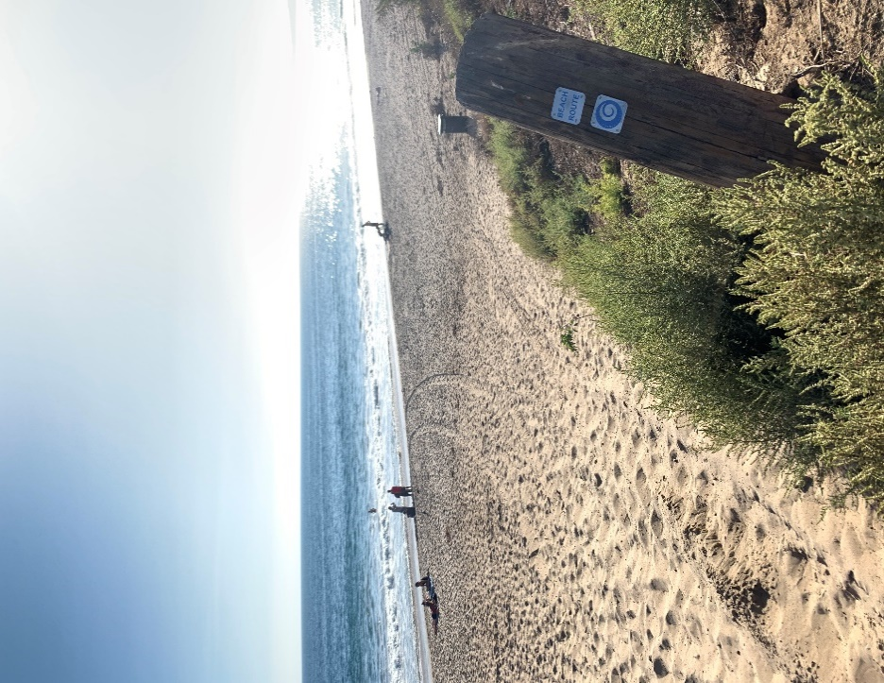
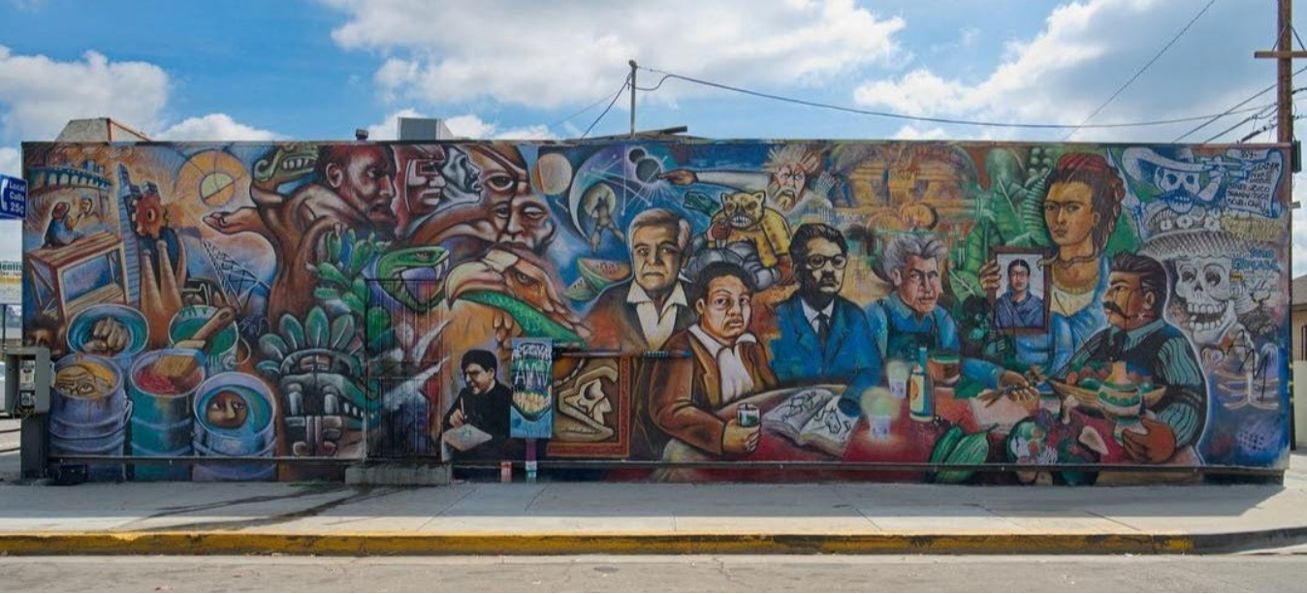
Deadline March 31, 2023
Pre-application is attached to this announcement as Attachment 2.
- Submit pre-application via email to grants@scc.ca.gov
- For questions, please email coastalstories@scc.ca.gov

Coastal Stories Grants Request for Pre-Applications

This RFP was updated on February 23, 2023. Changes are in red and underlined.

Introduction

The Conservancy’s Coastal Stories Grant Program will be providing grants to tribes, nonprofit organizations, and public agencies to create storytelling installations or materials (such as murals, signage, or monuments) that represent communities and voices that historically have been excluded from the storytelling on California’s coast and publicly accessible lands.

Pre-applications can be submitted via email to grants@scc.ca.gov. Pre-applications are due by 5 pm on March 31, 2023. Based on this review, applicants may be invited to submit a full grant application or asked to provide further information on their project.

About the State Coastal Conservancy

The State Coastal Conservancy (“Conservancy”) is a state agency established in 1976 to work proactively with local communities to implement multi-benefit projects that achieve its mission:
“The State Coastal Conservancy’s vision is of a beautiful, restored, and accessible coast for current and future generations of Californians. We act with others to protect, restore, and to increase public access to, California’s coast, ocean, coastal watersheds, and the San Francisco Bay Area.”
Our jurisdiction is the California coast, watersheds of coastal draining rivers and streams that extend inland from the coast, throughout the nine-county San Francisco Bay Area, and throughout the Santa Ana River watershed. Attachment 1 to this RFP includes a map of our jurisdiction.

Coastal Stories Grant Program Overview

Background
California’s coast and outdoors have long been recognized and used as spaces of joy, relaxation, community, and healing for many Californians. However, in these places across the state, the European-settler perspective dominates history and storytelling materials. This perspective teaches the public an incomplete history that often excludes Black, Indigenous, People of Color (BIPOC), immigrant, and other communities. As a result, these materials can send a message that some groups do not belong or are not welcome outdoors. To make California’s outdoor spaces more welcoming and inclusive, we want to increase the representation of BIPOC and other historically excluded groups by amplifying their voices, perspectives, and stories. This is the second round of Conservancy funding for this grant program.

Program Overview
The Conservancy’s Coastal Stories grant program will fund projects that develop and deliver installations and other products that represent the stories of BIPOC, immigrants, and other voices that historically have been excluded from California’s coast. By documenting and sharing these histories and stories, we aim to make outdoor spaces and interpretive centers feel welcoming and inclusive for all Californians.

The Coastal Stories grants build upon our existing Explore the Coast (ETC) program, funding projects that make the outdoors more welcoming to people and communities that face barriers to accessing or enjoying the coast. These communities may include but are not limited to BIPOC people, people with disabilities, immigrant communities, low-income communities, and other historically excluded communities.

These are the priorities of the Coastal Stories grant program:
- Promote a sense of belonging in outdoor spaces by presenting perspectives that include BIPOC and/or other historically excluded communities.
- Engage representatives of BIPOC and/or other historically excluded communities to develop and share their coastal perspectives and stories.
- Improve educational content in California’s outdoor spaces by correcting one-sided histories, retelling stories more appropriately and inclusively, and developing new content that shares untold stories.
- Use creative forms of community engagement.
- Create stories that are free and publicly accessible for the community and/or intended audiences.

Program Funding
Up to $1 million will be awarded in this grant round. There are no maximum or minimum grant amounts for this funding; however, it is anticipated that most grants will be up to $175,000. The budget for the requested amount should reflect the scale and effort required to implement the project.

Projects

Eligible Projects
Projects should research, develop, and present diverse stories of historically excluded communities in publicly accessible outdoor spaces. Proposals that use creative forms of historical, ecological, and cultural storytelling are encouraged. The Conservancy envisions that these storytelling materials will foster representation of BIPOC and other historically excluded groups in outdoor spaces, making the outdoors more inclusive and welcoming for all Californians.

All projects must present a story connected to outdoor spaces in a way that will reach the public. We encourage applicants to think through who their target audience is and how their project will reach that audience. We will fund planning and preparation activities such as hiring historians, storytellers, artists, community engagement, designing materials, acquiring permits and permissions, and the project's installation, creation, or implementation. Please see our Inclusive Interpretive Signage Guidelines for specific suggestions on producing inclusive content.

2023 Coastal Stories projects will be funded by Proposition 40, which is codified at Public Resources Code Sections 5096.600-5096.683. These funds may be used for “acquisition, development, rehabilitation, restoration, and protection of land and water resources.” Prop 40 defines “development” as: “improvement, rehabilitation, restoration, enhancement, preservation, protection, and interpretation.” It defines “preservation” as: “identification, evaluation, recordation, documentation, interpretation, protection, rehabilitation, restoration, stabilization, development, and reconstruction, or any combination of those activities.” Therefore, eligible projects include those that document and interpret land and water resources.

Examples of eligible projects:
- Developing and implementing storytelling products, including but not limited to signage, monuments, audio tours, maps, and guides. Video or audio-related content are fundable; however, the video or audio needs to be linked to QR codes on physical material.
- Hiring local artists or community members to design and implement murals or other visual art installations.
- Hiring a historian or community members to research and write content and develop storytelling products with this content.
- Adding storytelling or interpretive elements onto existing waterfronts, public accessways, interpretive centers, installations/education exhibits, etc., in free public spaces.
- Projects that use creative forms of storytelling not listed here are also encouraged to apply.

Examples of ineligible projects include:
- Hiring historians or community members to write content, without presenting this content in a way that will reach their intended audience.
- Primarily social media campaigns/content.
- Producing digital content that isn’t connected to a physical installation.
- Projects that provide excursions to the coast. Please see the Conservancy’s Explore the Coast grants for this type of funding.
- Construction projects that do not involve storytelling. Please note, however, that the Conservancy has funded hundreds of projects to build new trails, trailheads, and other amenities (beach stairways, bathrooms, overlooks, etc.) through other funding programs. Please contact us directly if you are pursuing this type of project.

We encourage you to contact us if you have any questions regarding the eligibility of your project: coastalstories@scc.ca.gov

Eligible Applicants
Federally-recognized tribes, nonprofit organizations, and public agencies are eligible for funding. To be eligible, a nonprofit organization must qualify under the provisions of Section 501(c)(3) of the Internal Revenue Code. Other community-based organizations and tribes that are not federally recognized may apply with a 501(c)(3) fiscal sponsor.

Partnerships
Partnerships between landowners and community-based organizations, historians, and other types of storytellers are highly encouraged. If the primary applicant is a landowner, they should detail how they partner or elevate underrepresented voices. If the primary applicant is a community storyteller, they should detail how they are partnering with, or have the cooperation of, the landowner for implementation and maintenance. We are willing to help community storytellers connect and build partnerships with landowners – you can find the Conservancy’s contact information on page 8.

If the applicant is not the landowner, they’ll need to provide a support letter from the landowner at the time of full-proposal submission. Please note that if selected for Conservancy funding, projects conducted on another entity’s land must have a signed landowner access agreement between the applicant and the landowner before the project can begin.

Maintenance Requirement
Most projects should be maintained for at least 15 years. Maintenance terms are based on the reasonable lifetime of each type of project. Conservancy staff can assist applicants with determining the maintenance requirement for their project.

Eligible Project Locations
Projects should take place on publicly accessible parks and lands within the Conservancy’s jurisdiction, which includes the coast, watersheds of coastal draining rivers and streams that extend inland, throughout the nine-county San Francisco Bay Area, and throughout the Santa Ana River watershed. A map of our jurisdiction is attached to this RFP.

Award Amount Per Project
There are no maximum or minimum grant amounts for this funding; however, it is anticipated that most grants will be up to $175,000.

Project Duration
Applicants should apply for projects that could start in early 2024. Projects must be completed by February 2027.

Copyright Release
Intellectual property rights in the projects produced under a Coastal Stories grant may be negotiated.

Applying for Funding

Pre-application Submittal
Applying for this funding program consists of a pre-application, followed by a full grant application upon invitation. The pre-application for this grant program is attached to this document, below.

Completed pre-applications should be submitted via email as a word document (file type .doc or .docx) to grants@scc.ca.gov. Applicants are welcome to attach a small number of relevant maps and photos (preferably as jpg) with their submission; these attachments should not exceed 10MB in total.

Please be aware that all documents submitted to the Conservancy become public documents. The Conservancy will assume that submitted photos are permissible for use by the Conservancy unless the applicant clarifies otherwise. Please indicate if photos, maps, or other material submitted with your pre-application and proposal require crediting when reused by the Conservancy. You should indicate this on each document.

Before pre-application submission, we recommend that applicants:
- Read through this full announcement.
- Participate in the optional technical assistance webinar or watch the posted webinar video if unable to participate live.
- Request an initial project phone or Zoom consultation to help determine if a project idea is eligible (see contact info in the following section). New applicants are highly encouraged to request a consultation prior to pre-application submission.
- Review the following materials for grantees on the Conservancy website to understand standard grantee requirements if your application were to be selected for funding.
  - Typical Grant Agreement Terms: https://scc.ca.gov/files/2020/05/Typical-Grant-Agreement-Terms.pdf
  - Grantee Manual: https://scc.ca.gov/grants/grantee-manual/

Next Steps in the Proposal & Grant Award Process
- Full Grant Application
Within 60 days of receipt of a pre-application, the Conservancy will notify the applicant in writing (email) that either (1) their pre-application is not eligible/competitive, (2) additional information or clarifications about the proposed project is required for further consideration, or (3) they are invited to submit a full grant application. For projects that align well with the purposes of Coastal Stories but are not adequately developed in the pre-application stage, Conservancy staff may provide guidance to help applicants to develop their project concepts further and re-submit the pre-application in this grant round.

Once invited to submit a full grant application, applicants will be provided with instructions and the full grant form. Applicants that are not the project area’s landowner will need to attach a letter of support from the landowner indicating their support. Email the completed proposal to the Conservancy at grants@scc.ca.gov. After you have submitted your full application, we ask that you fill out this anonymous short survey to help us improve our grant process in the future: https://www.surveymonkey.com/r/3TLJBYK.

Within 60 days of receipt of a full grant application: The Conservancy will notify the applicant in writing (email) that either (1) their full application will not be considered further, (2) their full application will require additional time for review, or (3) their proposed project will be recommended for funding at a future Conservancy meeting.

- Conservancy Authorization of Grant
Grant awards must be authorized by the Coastal Conservancy at a public meeting.
Conservancy staff plans to present projects at the November 2023 Conservancy board meeting held in Central CA, and virtually on Zoom. Conservancy staff will provide details about the board meeting and the steps following funding authorization, such as entering a grant agreement. Project funding will not be available until a grant agreement between the Conservancy and the grantee has been executed, which will generally take at least six weeks after board approval. Projects are expected to begin in late 2023 or early 2024 and must be completed by February 2027.

Grant Program Selection Criteria

The following criteria will be used to evaluate proposed projects:
- The extent to which the project meets Coastal Stories Program priorities:
  - Promote a sense of belonging in outdoor spaces by presenting perspectives that include BIPOC and/or other historically excluded communities.
  - Engage representatives of BIPOC and/or other historically excluded communities to develop and share their coastal perspectives and stories.
  - Improve educational content in California’s outdoor spaces by correcting one-sided histories, retelling stories more appropriately and inclusively, and developing new content that shares untold stories.
  - Use creative forms of community engagement.
  - Create stories that are free and publicly accessible for the community and/or intended audiences.
- The extent of leadership and participation by the community whose story is being told.
- The extent to which the project promotes a more inclusive experience in the outdoors for all Californians by considering differences in cultural and social backgrounds, past experiences, physical capabilities, knowledge, etc.
- Demonstration of meaningful outreach and community engagement in developing the story/ content.
- Demonstration that the project will reach its intended audience.
- Project description is clear, and the budget is reasonable.
- Project is ready to proceed in a timely manner (Projects are expected to begin late 2023 or early 2024, and must be completed by February 2027).
- Project includes a matching contribution.
- The applicant’s overall ability to carry out the proposed project, including having the necessary partnerships. The project team’s ability to maintain the project for its reasonable lifetime.
- Site feasibility (e.g. existing infrastructure, ADA compliance, permitting/zoning/park general plans, CEQA status, etc.).
- California Environmental Quality Act (CEQA) compliance – The Conservancy must consider how CEQA applies to each funding decision. Unless an exemption applies to the project or the work being funded, the required CEQA documentation must be complete before the Conservancy authorizes a grant. CEQA documentation does not have to be complete to apply for a grant.

In addition, proposed projects will be reviewed by the Conservancy staff for consistency with Division 21 of the Public Resources Code, Proposition 40, the Conservancy’s Strategic Plan, and the Conservancy’s general Project Selection Criteria.

Proposition 40 funding requires that “priority shall be given to projects that include a commitment for a matching contribution. Contributions may be in the form of money, property, or services.” Matching contributions could include funding or staff time (contributed by the applicant, project partners, or volunteers), donations of materials, or other services defined by the applicant. Match does not mean equal contribution and for the purposes of this grant program there is no threshold or minimum required for the matching contributions.

Projects are not required to commit matching contributions, but projects with match will get priority in the evaluation. If an applicant’s project is selected for an award, the applicant will need to document the matching contribution during the implementation of the project.

Contact Us for Assistance

Contact Information
Prospective applicants are encouraged to discuss their projects with the Conservancy staff before submitting their pre-applications. We are willing to help community storytellers connect and build partnerships with landowners. You can also reach out to us with questions about the proposal process. You may email any questions and requests for consultations to coastalstories@scc.ca.gov.

Technical Assistance Webinar
The Conservancy held a webinar on Wednesday, February 15, 2023, from 12:00 pm – 1:00 pm to walk through the Coastal Stories Grant Program and address common questions regarding the pre-application. The recorded webinar will be posted here: https://youtu.be/1E2OpDFhues

Attachment 1: State Coastal Conservancy Jurisdiction Map

STATE COASTAL CONSERVANCY

COASTAL STORIES GRANT

PRE-APPLICATION

Please submit your pre-application to grants@scc.ca.gov

Deadline for Pre-Application: 5 pm on March 31, 2023.

Contact Information
Organization:
Contact Person:
Email:
Phone:
Websites/Social Media Links:

Project INFORMATION
Project Name:
Amount Requested:
Location:
County:
Latitude, Longitude (e.g., 37.80630, -122.2735):
What point is represented by the lat/long (e.g. parking lot, the center of the site, etc.):

Directions: Please answer the questions below. Add lines below each heading as needed; the pre-application should be around 3 pages or less (not including maps or photos). Note that response lengths for each question are suggestions—we are looking for short and concise answers, but applicants will not be penalized for small deviations from the suggested response lengths.

- Project Description. Please describe the proposed project. Please explain the project’s goals and expected outcomes, including what story you would like to tell, what storytelling products will be created, and who the target audience is. Briefly describe the project location and attach a map of the project location (and photos if helpful). Be specific about the portion of the project that would be funded by this request. You may share additional materials as links or attachments to better explain your project to us (optional).

- Coastal Stories Program Priorities. Which Coastal Stories Program priorities does the project meet (check all that apply)? Briefly describe how the project meets each checked program priority in 1-2 sentences per priority.

☐ Promote a sense of belonging in outdoor spaces by presenting perspectives that include
BIPOC and/or other historically excluded communities.

☐ Engage representatives of BIPOC and/or other historically excluded communities to
develop and share their coastal perspectives and stories.

☐ Improve educational content in California’s outdoor spaces by correcting one-sided
histories, retelling stories in more appropriate and inclusive ways, and developing new
content that shares untold stories.

☐ Use creative forms of community engagement.

☐ Create stories that are free and publicly accessible for the community and/or intended audiences.

- Who’s Involved. List the organizations, agencies, and community-based partners that are involved with the project. In 2-3 sentences, describe each partner’s role in completing the project, specifying who the landowner is, and each partner’s involvement thus far in the project process. If they are not already listed as partners, please use 2-3 more sentences to describe in what capacity the community or tribal members are involved in developing the story.

- Project Schedule. Provide a project schedule that estimates the completion date of the major project tasks and any major milestones. Applicants can expect Coastal Stories funding to begin in late 2023 or early 2024. Projects must be completed by February 2027.

- Preliminary Budget. Please include the estimated total cost of the project, what activities you are requesting Conservancy funding for, and the proposed sources of additional funding. Include proposed funding sources even if they are not yet secured, but please make the status clear.
- Project Audience/ Community. In one to two paragraphs, describe the community or communities served by your project, the specific problem you will address with storytelling, and how you will reach the intended community/communities. Please include the metrics you will use to ensure the community(s) will benefit from the project.

- Pre-application Checklist. Please include the items on the following checklist as attachments to your pre-application.

 | Pre-application Item
☐ | - Completed Pre-application (around 3 pages or less)
 | - Project Location Map & Photos(see pre-application question #1)
☐ | - Additional visual or audio files that may help convey your project idea (optional, see pre-application question #1)
☐ | - Design Plans & Images (optional)
☐ | - Complete our survey to help us improve our grant process in the future: https://www.surveymonkey.com/r/3TLJBYK.

